# ***Adversaries & Attacks***

## Individuals

* Hacker/Cracker
  + Media uses term to refer to malicious individuals
  + Original motivation is for expert knowledge and the power that it might give them
    - Ham Radio, Phone Phreakers, Computer Geeks…
  + Covers a wide range of skill sets:
    - Script kiddies – download toolkits but no real idea how they work
    - Gray/black hats – skilled career hackers who may turn to cracking
      * Passionate, highly motivated, skilled
      * Not necessarily very coordinated
  + Present and learn new tricks via online conferences like DefCon
* Lone criminals
  + Goal is making money
    - Computers provide the environment and method
  + Often less skilled, will use toolkits happily
    - Audacious; use whatever works to give them money
* Insiders
  + Disgruntled employee can be very destructive
    - Especially if computer systems are very ‘open’
    - Usually operate a need to know basis
      * Military systems and authorisation levels/authentication
    - Can be restrictive and affect normal operations
      * Many security breaches occur because individuals get tired of using secure approach
    - Most destructive effects occur when the insider keeps quiet and works with outsiders

## Organisations

* Businesses
  + Always wanting to get competitive advantage
    - Might be interested in weaknesses in rivals
  + Usually to gain information of tactical value, e.g. design plans
  + Rare that they would actively attack and undermine competitor
  + Some businesses might buy out another company not for their product, but for their info
  + Example – Israeli Modi’in Ezrahi private investigators
    - Installed ‘trojan horse’ at businesses targeted by their clients
* Organised crime
  + Key player in security breaches internationally
    - More money to be made in online crime than smuggling drugs
  + Some organised crime networks are linked to governments
    - Russian Business Network
      * Alleged to provide infrastructure for majority of modern e-crime
      * Implicated in a lot of UK online crime
      * Alleged links to KGB and Russian mafia
  + Examples of information use
    - WoW account, $10
    - Skype Account, $12
    - Online banking account with $9,900 balance, $300

## Terrorists

* Two main goals of terrorist groups
  + Financial gain to fund activities – similar methods to criminal groups
  + Creating terror through control and destruction of critical infrastructure
    - Cheaper to stop a power plant rather than blow it up for example
* Nation states
  + When hackers, criminals and insiders team up, there is a problem
    - Cuckoo’s Egg, Cliff Stoll
      * One of first recorded instances of hacking US military sites and how it was tracked down to KGB
    - Israeli air attack on Syria
      * Command and control, radar systems switched off
    - Iranian uranium enrichment facilities: Stuxnet
    - Infrastructure control plants
    - Might try and hack via another country to hide source
    - Honeypots
  + NSA/GCHQ & PRISM, NSA/BND & XKeyscore
  + Russia
    - Russian malware turning up in infrastructure
    - Control facilities
    - NotPetya
  + China
    - 600+ US targets over last 5 years
  + North Korea
    - Sometimes take viruses already out there, modify and rerelease them for their own gains
* Mindset has changed with security
  + Rather than prevent attacks, now assume they are already in the system
    - How can you protect your data?
* Beginning to escalate
  + Brian Krebs – assume org is compromised and react accordingly
  + Bruce Schneier – on brink of cyber war
  + Tim-Berners Lee – very sad with the way WWW has gone

## Crime

* Criminal attacks
  + Goal is usually financial gain
  + Fraud
    - 419 scams – originates from Nigerian Criminal Code
      * Relies on greed
      * Originally large source of spam email
    - Phishing – creating false website/login account to harvest user details
      * More and more prevalent
      * Gain access to account details
      * XSS and recent DNS bug make it a dangerous threat
        + You probably have not written all your site’s JavaScript
    - Spear phishing
      * Contains elements the recipient might be expecting
    - Virus laden or spoofed emails purporting to come from legitimate user
      * User opens fraudulent attachment which installs Trojan virus
      * Many different types of attachment are dangerous: **exe, pif, bat, zip**
  + IP Theft (aka Piracy) – covers broad range of topics
    - Design documents
    - Source code
    - Software applications – ‘warez’
      * Good way to get a trojan
      * Even hackers get back doored
    - Music, videos, games
    - Digital media is relatively easy to copy and disseminate
  + Identity Theft
    - Stealing a person’s identity can be very damaging and cause significant frustration for the affected victim
      * Authentication processes for creating new accounts are often very weak and have not kept up with fraudsters
  + Data theft
    - Common form of attack where goal is to obtain confidential data w/ aim of using for financial gain, e.g. user account details, credit card numbers
    - Frequently the aim of website attacks where such info is normally stored
    - E.g. Marriott hotel chain – 500 million details stolen

## Privacy

* Targeted surveillance
  + Small group or even an individual may be singled out due to the potential to exploit them financially, politically, or militarily
    - Standard technique might be to install a key listener via a Trojan or eavesdrop on network communications
  + Precrime systems
* Data harvesting
  + Commonly, attackers listen on computers and network communications and look for interesting patterns, e.g. text fields in forms with names like ‘password’
  + Storage of such data is less of an issue; the bigger concern is analysing the vast amount of data that can be generated
* Traffic analysis
  + Looks at not just what you say, but who you say it to
  + Part of ‘metadata’ of communications and can reveal a lot about an individual
  + Russia and China (and apparently UK) are pulling a Minority Report
  + Lots can be found out just from telephone conversations alone
* Key analysis
  + Often used by military and law enforcement to identify key individuals
    - ECHELON and NSA/GCHQ monitor and analyse network traffic for this purpose
    - Look for certain communication patterns or tags in data to identify individuals and computers they use
    - Potential terror cells have a comm structure that is relatively unique
      * First spot the structure, then investigate further
      * Scanning for network structures is much quicker than looking at actual conversations
* Summary
  + Looked at different types of adversary and attacks
    - Adversaries
      * Individuals
      * Organisations
    - Attacks
      * Criminal
      * Privacy
      * Publicity
  + Next:
    - What principles should we adopt to build a secure system
    - What technologies can we use to build them

# ***Security Requirements***

## Privacy

* Confidentiality and privacy
  + Core requirement of a secure system is to preserve confidentiality by protecting privacy
    - Privacy issues predate computers; motivated by fundamental human rights
    - People and societies differ on what they consider what data should be private
    - With computers and modern media, once privacy is transgressed, can be difficult to reverse
  + Prior to computers publicly available data was rarely accessed due to difficulties in finding it
    - Can now use google to achieve a lifetime’s work, i.e. tracking down genealogy
    - Cross referencing different data sources allows you to build detailed pic of individual
      * Maybe do not need to know their name at all
* Privacy and society
  + EU – data about you is private to you
  + US – data belongs to company and may be freely sold on
  + Most obvious effect is direct marketing approaches
  + Level of privacy afforded to individual often defines how liberal the society is
* GDPR
  + Came into effect on 25th May 2018
    - Designed to protect privacy of individual and control how organisations store and access confidential EU citizen info
    - Seven key principles
      * Lawful fair and transparent processing
      * Data minimisation
      * Accurate processing
      * Limitation of storage
      * Personal data should be kept secure
      * Lawful and legitimate purpose
      * Accountability for storage and processing of data
  + Also, RIPA act allows lots of government agencies to request web browsing data from ISP
  + If something is free, you are the product…
* Anonymity
  + Protects privacy since although you may know facts about a person, it is harder to cause harm if you do not know who they are
  + Anonymity has many benefits
    - Removes bias
    - Whistle-blowers
    - Removes barriers to interaction with untrusted parties encouraging people to get involved/investigate/contribute if they are not traceable
      * Can be good and bad
    - What about payment and delivery if anonymous – convenient but easy to defraud or exploit
  + Pseudonymity
    - Common for of avoiding anonymity issues
      * People and organisations can regularly interact with pseudonym without you giving away too much personal info

## Authentication and Integrity

* Authenticity
  + Who are you?
  + What are you allowed access to?
  + Authentication is the process of identifying an individual as being genuine
    - Systems frequently attempt authentication by checking something a user:
      * Knows – password, PIN, DOB
      * Has – Card, key, badge
      * Is – face, fingerprint, iris scan
    - System is more secure if it combines two or more of these factors for authentication
* Authorisation
  + Concerned with what user can do
  + If we accept they are who they say, must restrict what they can do
    - Often to protect systems they are working on
    - Sometimes to protect them from themselves
    - Typical levels on computer
      * User – create files in their own space, view local documents, cannot install software
      * Manager – edit documents in project workspaces
      * Administrator – install software, configure printers, manage accounts
    - Military systems have many info access levels
      * Public, restricted, secret, top secret etc.
      * Problems can occur when user needs access to part of data only manager can see for example
* Integrity
  + Ensuring information is genuine
    - Has the data or system maintaining it been tampered with (e.g. a website)
    - Data which has maintained integrity is not necessarily an accurate reflection of real world, just reflects what was recorded
  + Undermining integrity of information can have dramatic effects
    - Attempts can be made to lure you to fake site – ‘phishing’
    - Uncertainty or loss of confidence in the value of something is damaging
      * Stock prices, criminal records…
  + Web based media is very powerful
    - Potential damage by manipulating truth is high
    - Once achieved, very hard to undo deceit
  + Accountability acts as insurance for data integrity
    - Involves keeping a log of relevant events, who and when carried out
    - By keeping a careful audit trail, it should be possible to observe any change to data and identify the person responsible for the change
      * Data can be ‘rolled back’ to original values
      * Person can be questioned, and trail followed further
      * Auditing and version control occurs in large SW dev process
* Audit
  + Ability to conduct methodical and thorough review of system and its users
    - Recording actions of system and users
    - Audit may prevent attack if dissuades attacker due to audit trail left behind
    - Skilled hackers can cover up
    - Without proper audit, very difficult to trace an attack and work out what was done
  + Forensics
    - Identifying what happened, how, when, and why relies on good auditing
* Availability
  + Concerned with provision of robust systems and software that can provide reliable service
    - Should be developed from defensive programming aspect where external input not trusted and as few assumptions as possible are made about outside world

# ***Cryptography***

## Concepts

* Cryptography
  + Plays significant role in meeting security requirements of
    - Confidentiality
    - Authenticity
    - Integrity
  + Encrypted data is private data
    - Eavesdropper would need to know the encryption method and the key used
  + Important in authentication
    - Passwords
    - Certificates
  + Encrypted data can be tied to a unique key or ‘digital fingerprint’ that will not match if data has been altered since key was made
    - Cryptographic Hash/Checksum Functions
    - Message Digests (e.g. SHA, MD5)
      * MD5 quite crackable nowadays
* Terminology (for examples)
  + sender – originator of message
  + plaintext – clear message
  + encryption – process of turning plaintext into cipher text
  + cipher text – encrypted and unreadable message
  + decryption – process of turning cipher text into plain text
  + receiver
* Notation (for examples)
  + formal notation useful for describing processes involved in cryptography

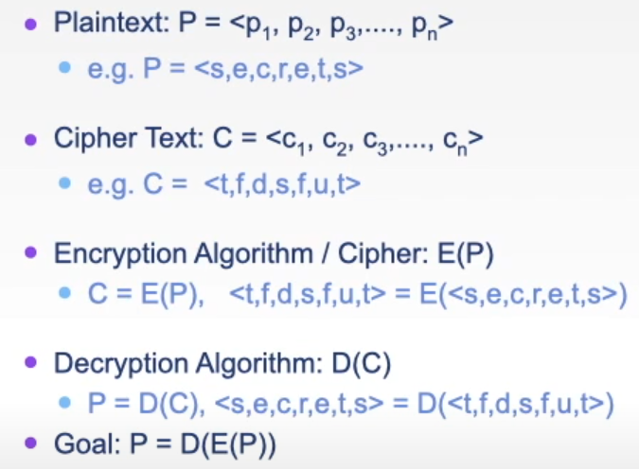

## Symmetric Encryption & Keys

* Symmetric encryption
  + Encryption methods can use one or more keys to adjust operation of encryption algorithm such that we get different C for each K

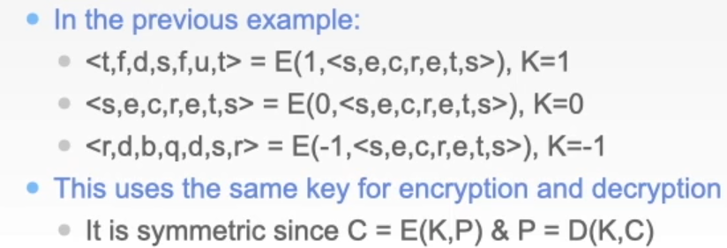

* Asymmetric encryption
  + Different key to encrypt a message compared with the one needed to decrypt it



* + About 10,000 times more work than symmetric encryption

## Ciphers

* Secret messages have been encrypted for millennia
  + Early focus was on transmission of secret messages (cipher text) and their subsequent decoding, whilst trying to prevent eavesdroppers from decoding them
    - Chinese, Greeks, Romans…
    - Caesar cipher
  + Two common approaches
    - Substitution cipher – substitute plain text character for cipher text character, e.g. Caesar Cipher
    - Transposition cipher – rearrange message characters
    - Goal is to diffuse
* Substitution ciphers
  + Replacing each plain text character with a cipher text character
  + Table of character mappings is created which instructs coder on which character to se to substitute for plain text character
    - Even if substitution table is more irregular, patterns can be determined in cipher text
* Book cipher
  + Straight sub ciphers produce regular patterns in cipher text which can be matched to frequently occurring words or letters
  + Provides stronger form of substitution cipher that can hide the regular patterns
    - Phrase from book or some agreed data source is aligned with plain text, and cipher text derived



* + - To decipher cipher text, we reverse the process



## Transposition/Permutation Ciphers

* Trans ciphers transpose data items according to rules of cipher
  + Aim to diffuse message in cipher such that no obvious structure can be determined – more complex the cipher the more likely this is to happen
  + Common trans ciphers
    - Route cipher
    - Columnar cipher
* Route ciphers
  + Lays message out in grid, then traverses it in specified route – cipher is the route to take

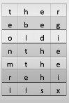

* Columnar cipher
  + Specialised forms of route cipher where we read columns in an order determined from a key
  + E.g. encrypt the plain text ‘there be gold’ with the key ‘shoe’
    - Count letters in key ‘shoe’
    - Arrange letters in 4x4 grid, padding out with rarely used letters (spaces normally added)
    - Label columns with key letters
    - Read off grid columns in alphabetic order of key letters
      * Column ‘e’ then ‘h’ then ‘o’ then ‘s’

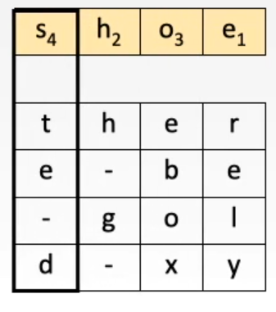

* + - Result: relyh-g-eboxte-d
  + To extract plain text
    - Count letters in key
    - Create 4x4 grid with key letters as column headers
    - Put first four letters in cipher text in column ‘e’, next four in column ‘h’ and so on
    - Now read off grid rows from top to bottom
    - Result: ‘there be gold’
      * Would not normally use ‘-‘ spacers, just makes it easier to read
    - Could use two keys to give different column and row dimensions
    - Repeating process on first stage cipher text with another key makes it much harder to break but also longer to decipher

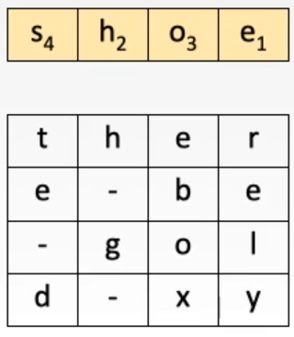

## Cryptanalysis

* Cryptanalysis is the process of breaking ciphers
* Methods
  + Break given cipher-text to decode message
  + Recognise general pattern allowing all messages to be deciphered
  + Infer meaning by noting communication patterns rather than content
  + Determine key and algorithm thus negating encryption method
  + Determine if poor use made of encryption method
    - E.g. repeated use of one-time pad or repetition at the start of a message
  + Find mathematical weaknesses in the encryption algorithm and exploit them
* Breakable encryption
  + Algorithm is theoretically breakable if
    - A cryptanalyst could determine cipher text given sufficient time and data by working through all options and checking which appear valid
    - If algorithm is suitably hard, it is practically unsolvable (at least in universe’s lifespan)
    - Cryptanalysts will not usually try and solve it this way
* Attacks
  + Type of attack used to break cipher depends on its type
    - Symmetric
      * Brute force
      * Look for patterns
    - Asymmetric
      * Algorithm is frequently known
        + Challenge is to determine the key
        + This is mathematically challenging
* Looking for patterns
  + Given sufficient cipher text, straight sub cipher is easy to break
    - Look for frequent patterns that can be matched to common language traits
    - Longer the text, more likely these frequencies will match

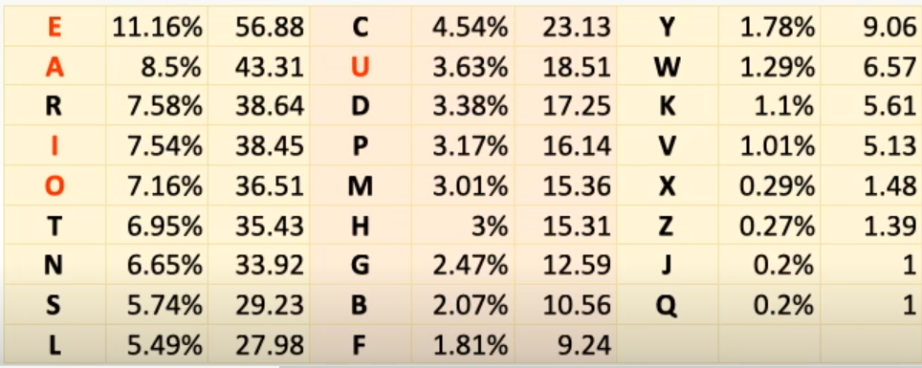

* + Certain words are more frequent than others
    - If certain patterns occur in cipher text a cryptanalyst can try small subsets of substitutions to see if they make sense
    - Once certain word/letter subst. are worked out they can be crossed off the check list, reducing search space
    - Once matches are made, clues to the likely subst. algorithm
* Shannon’s rules
  + Required secrecy should determine effort involved in encryption/decryption
    - Simple cipher might sometimes be more relevant than a time consuming one
  + Set of poss. Keys should be simple and relatively unrestricted
  + Implementation of encryption algorithm should be as simple as is practicable
  + Errors introduced in cipher process should not propagate and corrupt rest of message
  + Cipher text size should not be larger than plaintext
  + Advent of computers has negated some of these issues but are cases when they remain relevant
* Stream and Block Ciphers
  + Two common forms of ciphers:
  + Stream
    - Encipher plaintext one character at a time as it is received – e.g. subst. cipher
    - Does not require complete message before encryption process can begin
    - Useful for telecommunications where ‘stream’ of data is sent
    - **Advantages**: speed, low error propagation
    - **Disadvantages**: weak/no diffusion
  + Block
    - Encipher blocks of plaintext at a time – e.g. route cipher
    - Requires data to be collated together in chunks
    - Some block ciphers require complete message before encryption can proceed
    - Block can make it harder to break cipher since patterns in plaintext are lost
    - **Advantages**: strong diffusion
    - **Disadvantages**: relatively slow, susceptible to error propagation
* Confusing vs diffusing
  + Encryption algorithms aim to *confuse* a cryptanalyst and *diffuse* the plaintext info throughout the cipher text
  + Confusion
    - Changing one plain text letter should not enable a cryptanalyst to determine the effect on the cipher text
    - Straight sub ciphers are not confusing – an immediate one to one relationship is evident
    - One-time pads/book ciphers will confuse since not a one to one relationship between plaintext characters and eventual cipher text equivalent
  + Diffusion
    - Aims to spread plaintext information through cipher text such that adjacency patterns are not obvious or present
    - More diffusion created by the cipher, more of cipher text that will be needed to break it

## Using Encryption Algorithms

* Commercial encryption
  + Commercial grade encryption systems should:
    - Be derived from solid mathematical principles
    - Analysed and tested by experts – peer reviewed
    - Withstand repeated real-world use
  + Current commercial grade encryption algorithms
    - DES – Data Encryption Standard
    - RSA – Rivest-Shamir-Adelman
    - AES – advanced encryption standard
* DES
  + Symmetric key cipher (private key)
  + Method
    - Applies 16 iterations of substitution and diffusion
    - Uses standard arithmetic and logical operators
      * Remember we are working with bytes, not grids of characters like in example
    - Plaintext can be values requiring up to 64 bits to encode them
    - Suitable for operation on a standard PC or chip
    - Weak 56 bit key
* RSA
  + Asymmetric cipher, public & private keys
    - Still regarded as secure despite many attempts to break it
    - Either key can be used as public or private key
    - Plaintext block P is encoded

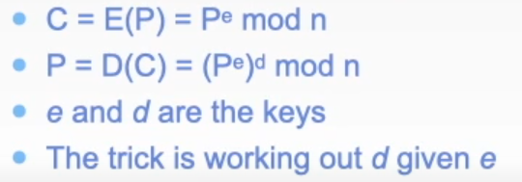

* + - Utilises factoring of large prime numbers to prevent cracking
* AES
  + Symmetric (private key)
    - Fast
    - Substitution and transposition
    - Repeat cycles of 10, 12, 14
    - Key length of 128, 192, 256 bits
    - Algorithm permits extension to more cycles and larger keys
  + Cycle steps
    - 128-bit blocks use 8-bit substitutions – diffuses data
    - Logical shift – creates a transposition
    - Shift and Exclusive Or – adds both confusion and diffusion
    - Add sub key element – adds confusion and introduces key binding

## Cryptographic Hash Functions

* Encrypted data can be tied to a unique seal or hash value
* This seal will not match if data has been altered since key was made
  + Sally generates hash of data which uniquely ids it
  + She sends the data and its hash
  + Rob can check the received data generates the same hash that sally sent
  + If Eve wants to alter data, she will need to make sure it generated the same hash that Sally published
  + If data has been altered, integrity is lost, and the hash values will not match
* Hash values functions are based on one-way functions
  + Easy to compute in one direction but not in reverse direction
    - Adjacent input values should produce widely different output values
    - Looking only at output, it should be near impossible to work out what input that generated it was
  + One-way hash of message is quickly computed and provides a seal for the message
    - Because it is difficult to work backwards, it is extremely hard to work out how to adjust the message and still get the same seal
    - DES and AES allow for addition of this hash to the end of the encrypted message
  + Message Digest 5 (MD5) and Secure Hash Algorithm (SHA) are popular cryptographic hash functions
    - MD5 produces a 128-bit signature or digest for any given message
    - SHA produces a 160-bit digest

## Public Key Encryption & Key Exchange

* Asymmetric keys enable a receiver R to ask a sender S to send a message that only R can decode, even though R has published an encryption key
* What if you want to establish trusted two-way communication process?
  + Want to communicate but want to guarantee messages are coming from correct person
  + Cannot use symmetric key approach since it would involve publishing this private key for communication to occur
  + Need two sets of public and private keys



* Key exchange process

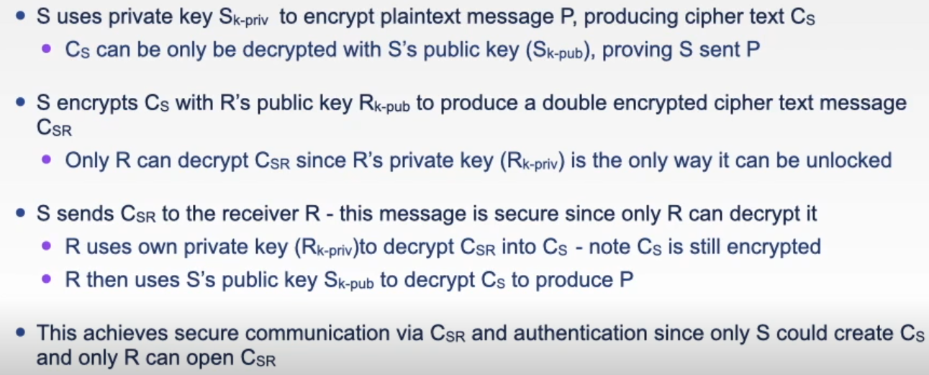

* https uses this method

## Key Exchange – Diffie Hellman

* provides means of creating a private shared key even though an eavesdropper is listening in on comm process used to set it up
* sender and receiver publicly agree and transmit two numbers
  + very large prime modulus p
  + generator g (which neds to be a primitive root of the above)
  + sender and receiver each decide on private number s and r respectively and each perform the following calculation to create a message m

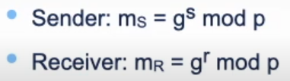

* + they publicly exchange the values mS and mR
  + eavesdropper will not have access to the two private numbers
  + on receipt of each other’s messages, the sender and receiver perform a further calculation:

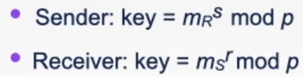

* + value of key should be the same and is the private key they will agree to use in a subsequent symmetric key based communication algorithm
  + to work out what the key value is, you would have to solve the discrete logarithm problem
    - very hard to solve for large values of prime modulus p

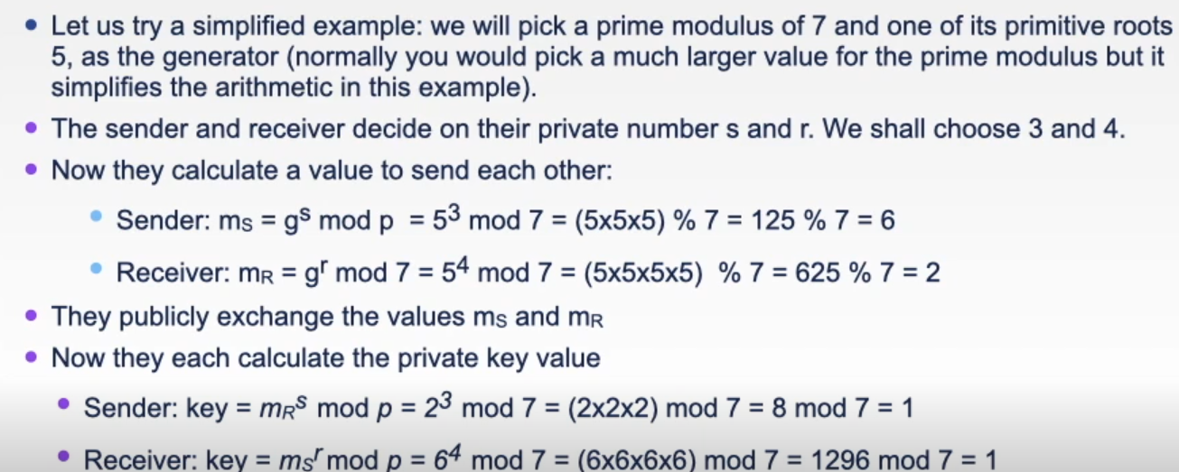

## Digital Signatures

* Digital signatures need to be:
  + Unique – cannot forge someone else’s signature
  + Authentic – sender S should be the only entity able to send a given signed message
  + Immutable – cannot be changed by sender S or receiver R once it is signed
  + Finite – sender should not be able to send the same message twice (e.g. cashing a check twice)
* Method
  + Asymmetric digital signatures rely on the fact that algorithms such as RSA are commutative

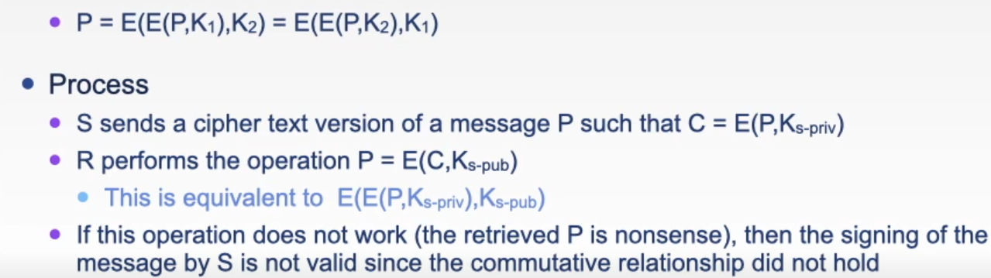

## Certification of Digital Signature

* Certification
  + Developer
    - Generates their own public/private key pair
    - Creates a certificate Signing Request (CSR) containing ID and public key
      * Private key used to sign request
    - Sends CSR to Certificate Authority (CA)
  + Certificate Authority
    - Checks integrity of CSR
    - Checks authenticity of CSR ID
    - CA creates a certificate containing identity and signed via CA private key
    - CS public key is available allowing CA signature to be checked via decryption
* Certification Process
  + Dev publishes an app (e.g. web or PDA app)
  + Signs it with their private key and provides CA signed certificate as verification
  + Developer’s public key verifies the app, the CA’s public key decrypts the certificate and indicates that the developer’s identity is valid
* Certificate authorities
  + Digital certificates are used to enable trust to be established between two parties who have never met but wish to exchange info securely
    - Principle based on a hierarchy of trusted third parties or ‘Certificate Authorities’
    - Each party uses the authority above them to determine if they can trust the other
    - Requests are traced up the tree until a common trusted connection is found (or not)
    - For example, A establishes trust between C & E
* Process
  + Actual process works in reverse, where each parent node in the tree vouches for the node directly below it
    - Each node collects a certificate chain for all the nodes above it
    - If trust needs to be established, two people can check their cert list to determine if there is a common trusted connection
    - Once common link found, rest of chain can be cross-checked to ensure it matches all the way to the top
  + For any given entity in the chain
    - Their public key and identity are combined in a cert which is then digitally signed by the authority above them and passed up to the next parent authority and signed again
    - Final cert is composed of all the appended certificates of the parent authorities plus the original certificate
    - One problem – who vouches for the authority at the top given the internet is a distributed organisation
* Summary
  + Symmetric and asymmetric encryption
  + Cryptographic algorithms
  + Cryptographic attacks
  + Creating encryption algorithms
  + Using encryption
    - Commercial encryption
    - Cryptographic hash functions
    - Public key encryption
    - Digital signatures
    - Certificates
* Further reading
  + Computer Security, Chapters 20 & 21
  + The Code Book – Simon Singh

# Networks

## What is the internet

* What is the internet
  + Network of networks
    - Mobile network
    - Global ISP
    - Home network
    - Regional ISP
    - Institutional network
  + Millions of connected computing devices
    - Hosts = end systems
      * Running network apps
  + Comm links
    - Fibre, copper, radio, satellite
    - Transmission rate = bandwidth
  + Routers
    - Forward packets (chunks of data)
  + Protocols control sending and receiving of messages
    - TCP, IP, HTTP, Skype, Ethernet
  + Internet: @network of networks”
    - Loosely hierarchical
    - Public internet
    - Private intranet
  + Internet standards
    - RFC: Request For Comments
    - IETF: Internet Engineering Task Force
  + Comm infrastructure enables distributed apps
    - Web, VoIP, email, games, e-commerce
  + Comm services provided to apps
    - Reliable data delivery from source to destination
    - “best effort” data delivery (unreliable)
* What is a protocol
  + Protocols
    - define format, order of msgs sent and received among network entities
    - actions taken on msg transmission and receipt

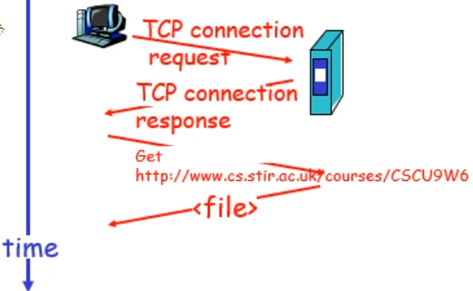

## Network Edge

* Closer look at network structure
  + Network edge
    - Apps and hosts
  + Access networks, physical media:
    - Wired, wireless comm links
  + Network core
    - Interconnected routers
    - Network of networks (internet)
* Network edge
  + End systems (hosts)
    - Run app programs
    - E.g. web, email
    - At “edge of network”
  + Client/server
    - Client host requests and receives service from always-on server
    - E.g. web browser/server; email client/server
  + Peer-peer model
    - Minimal or no use of dedicated servers
    - E.g. Skype, BitTorrent
* Access networks and physical media
  + How to connect end systems to edge router
    - Residential access nets
    - Institutional access networks (schools, companies)
    - Mobile access networks
  + Keep in mind
    - Bandwidth (bits per second) of access network
    - Shared or dedicated
* Residential access: point to point access
  + Dialup via modem
    - Up to 56Kbps direct router access
    - Can’t surf and use phone at same time
  + DSL: digital subscriber line
    - Deployment: telephone company (typically)
    - Up to 1Mbps upstream
    - Up to 43Mbps downstream
    - Dedicated physical line to telephone exchange
    - FTTN (fibre to the network) allows up to 170Mbps

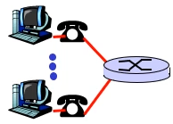

* Residential access: Cable modems
  + HFC hybrid fibre coax
    - Asym: up to 30Mbps downstream, 2Mbps upstream
  + Network of cable and fibre attaches homes to ISP router
    - Homes share router access
  + Deployment: available via cable TV companies
* Company access: LAN
  + Companu/unix LAN connects end system to edge router
  + Ethernet
    - 10Mbs, 100Mbps, 1Gbps, 10Gbps ethernet
    - Modern config: end systems connect into Ethernet switch
  + LANs: later lectures

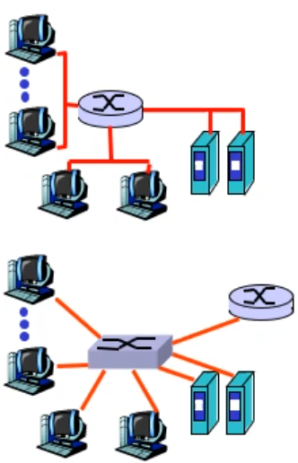

* Wireless access networks
  + Shared wireless access network connects end system to router
    - Via base station, aka “access point”
  + Wireless LANs
    - 802.11b/g (WiFi): 11, 54, 108 Mbps
  + Wider-area wireless access
    - Provided by telco operator
    - 4G/5G…

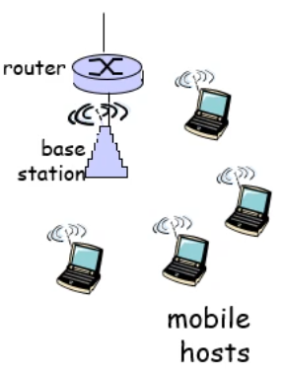

* Home networks
  + Typical home network components
    - DSL or cable modem
    - Router/firewall/NAT
    - Ethernet
    - Wireless access point
  + Router has firewall and IP address
    - All devices in house have private IP that is not publicly routable
    - Allows router to map internet IP to router address and port number

## Network Core

* Network core
  + Mesh of interconnected routers
  + Fundamental question: how is data transferred through net?
    - Circuit switching: dedicated circuit per call: telephone net
    - Packet-switching: data sent through net in discrete “chunks”
* Circuit switching
  + End-end resources reserved for “call”
    - Link bandwidth, switch capacity
    - Dedicated resources – no sharing
    - Circuit-like (guaranteed) performance
    - Call setup required
  + Network resources divided into pieces
    - Pieces allocated to calls
    - Resource piece idle if not used by owning call (no sharing)
    - Dividing link bandwidth into “pieces”
      * Frequency division
      * Time division
  + FDM and TDM

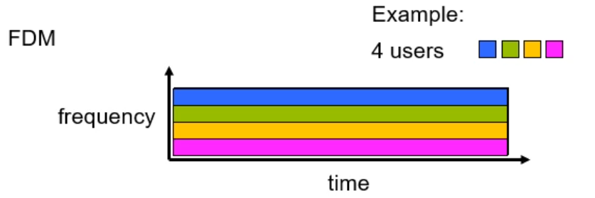

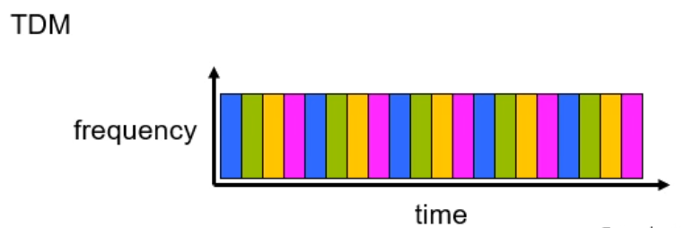

* Packet switching
  + Each end-end data stream divided into packets
    - User A, B packets share network resources
    - Each packet uses full link bandwidth
    - Resources used as needed
  + Resource contention
    - Aggregate resource demand can exceed amount available
    - Congestion: packets queue and wait for link use
    - Store and forward: packets move one hop at a time
      * Node receives complete packet before forwarding
  + Statistical multiplexing

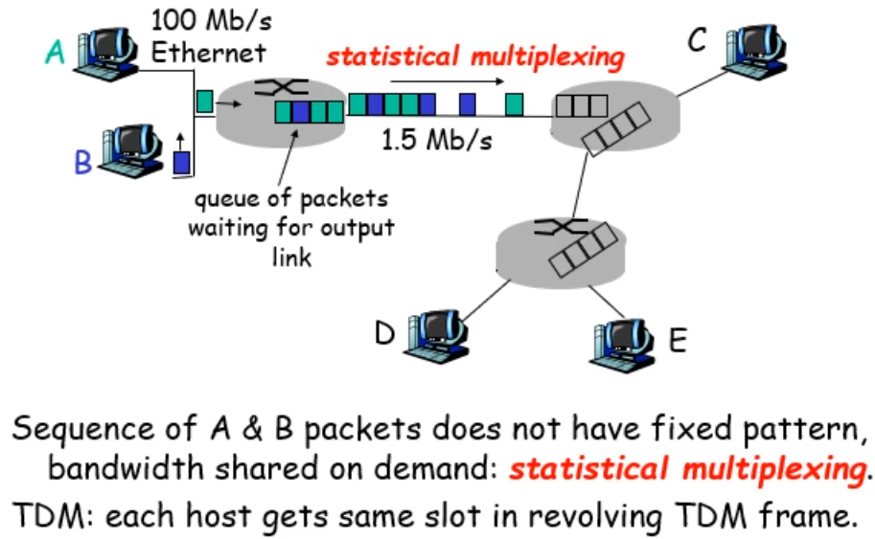

* + Store-and-forward
    - takes L/R seconds to transmit packet of L bits on to link at R bps
    - store and forward: entire packet must arrive at router before can be transmitted on next link
    - delay = 3L/R (assuming zero propagation delay)



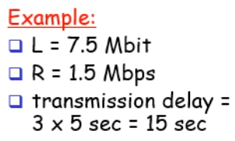

* Packet vs Circuit Switching
  + Packet switching allows more users to use network
  + 1Mb/s link
    - Each user:
      * 100kb/s when “active”
      * Active 10% of timeS
  + Circuit-switching:
    - 10 users
  + Packet switching
    - w/ 35 users, prob > 10 active at same time is less than .0004

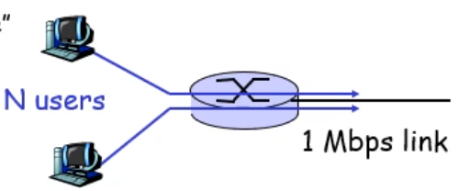

* + is packet switching better?
    - Great for bursty data
      * Resource sharing
      * Simpler and no call setup
    - Excessive congestion
      * Protocols needed for reliable data transfer, congestion control
    - How to provide circuit-like behaviour?
      * Bandwidth guarantees needed for audio/video apps
      * Still an unsolved problem

## Delay, loss and throughput in packet-switched networks

* How do loss and delay occur?
  + Packets queue in router buffers
    - Packet arrival rate to link exceeds output link capacity
    - Packets queue, wait for turn

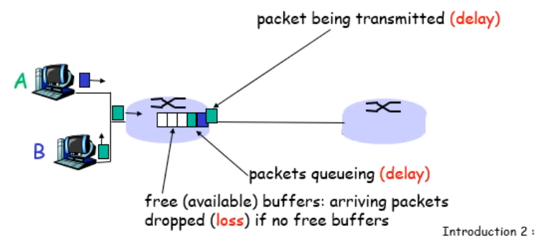

* Four sources of packet delay
  + Nodal processing
    - Check bit errors
    - Determine output link
  + Queueing (by far the most significant of the 4)
    - Time waiting at output link for transmission
    - Depends on router congestion
  + Transmission delay
    - R=link bandwidth (bps)
    - L=packet length (bits)
    - Time to send bits into link = L/R
  + Propagation delay
    - d=length of physical link
    - s=propagation speed in medium (~2x10^8 m/sec)
    - Prop delay = d/s

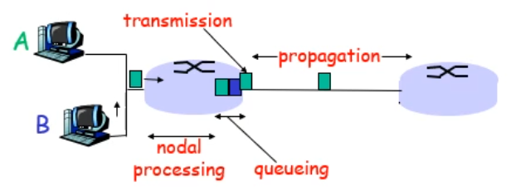

* Nodal delay
  + dnodal = dproc + dqueue + dtrans + dprop
  + dproc = processing delay
    - Few microsecs or less
  + dqueue = queuing delay
    - Depends on congestion
  + dtrans = transmission delay
    - =L/R, significant for low-speed links
  + dprop = propagation delay
    - A few microsecs to hundreds of msecs
* Queuing delay
  + R=link bandwidth (bps)
  + L=packet length (bits)
  + Traffic intensity = La/R
  + La/R ~ 0: average queueing delay small
  + La/R -> 1: delays become large
  + La/R > 1: more “work” arriving than can be serviced, average delay infinite!

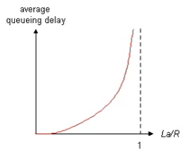

* Packet loss
  + Queue preceding link in buffer has finite capacity
  + Packet arriving to full queue dropped
  + Lost packer may be retransmitted by previous node, by source end system, or not at all
* Throughput
  + Rate at which bits transferred between sender/receiver (bits/time unit)
    - Instantaneous: rate at given point in time
    - Average: rate over longer period

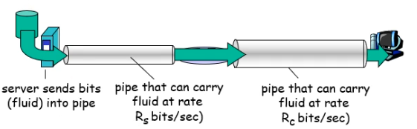

* + Bottleneck link: link on end-to-end path that constrains end-end throughput
* Throughput: internet scenario
  + Per connection end-end throughput: min(Rc,Rs,R/10)
  + In practice Rc or Rs is often the bottleneck

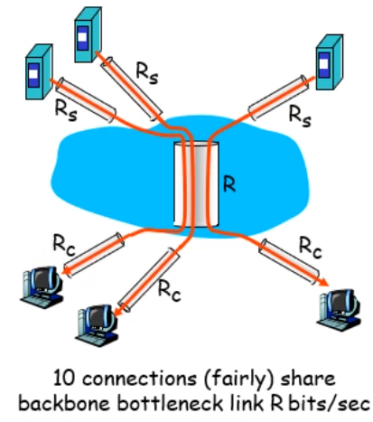

## Protocol layers, service models

* Protocol layers
  + Networks are complex: many pieces
    - Hosts
    - Routers
    - Links of various media
    - Apps
    - Protocols
    - Hardware/software
  + How do we organise this?
* Why layering?
  + Dealing with complex systems:
    - Explicit structure allows ID, relationship of complex system’s pieces
      * Layered ref model for discussion
    - Modularization eases maintenance, updating of system
      * Change of implementation of layer’s service is transparent to rest of system
      * E.g. change in gate procedure does not affect rest of system
    - Layering considered harmful
      * Too many layers; lots of interfaces and things to deal with
* Internet protocol stack
  + App: supporting network apps
    - FTP, SMTP, HTTP
  + Transport: Process-process data transfer
    - TCP, UDP
  + Network: routing of diagrams from source to destination
    - IP, routing protocols
  + Link: data transfer between neighbouring network elements
    - PPP, Ethernet
  + Physical: bits “on the wire”

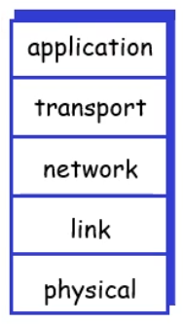

* ISO/OSI reference model
  + Presentation: allow apps to interpret meaning of data, e.g. encryption, compression, machine-specific conventions
  + Session: synchronisation, checkpointing, recovery of data exchange
  + Internet stack “missing” these layers
    - These services if needed must be implemented in app
    - This one is just a reference model; not really used in practice

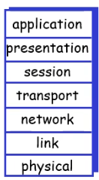

* Encapsulation
  + When header added at different layers, they have different names:
    - Application: message
    - Transport: segment
    - Network: datagram
    - Link: frame
    - Physical

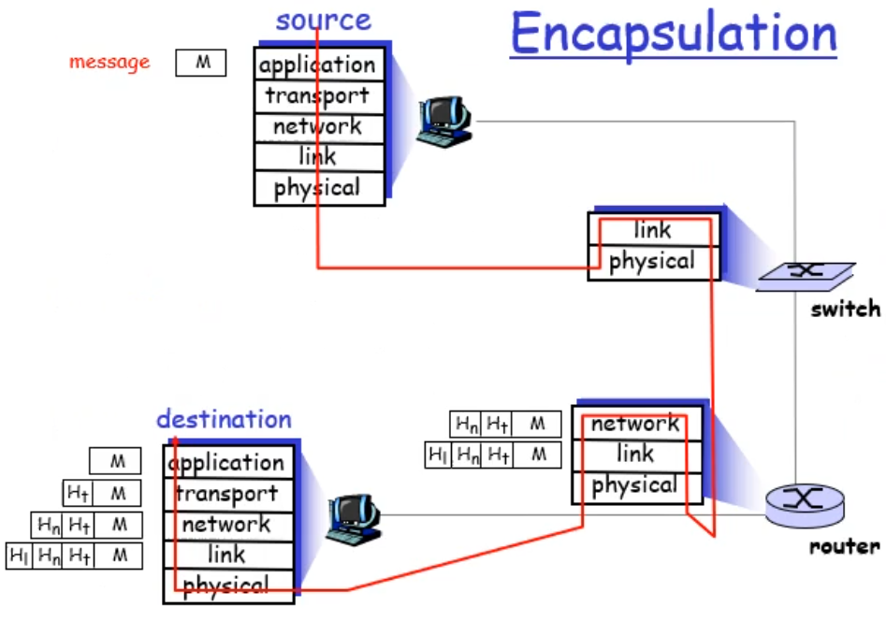

# Applications

## Introduction

* Some network apps
  + E-mail
  + Web
  + Remote login/desktop
  + P2P file sharing
  + Instant messaging
  + Video conferencing
  + Cluster/cloud computing
* Creating a network app
  + Write programs that
    - Run on different end systems
    - Communicate over network
    - E.g. web server software communicates with browser software
  + No need to write software for network-core devices
    - Network-core devices do not run user applications
    - Applications on end systems allows for rapid app development, propagation
* App architecture
  + Client-server
  + P2P
  + Hybrid of client-server and P2P
* Client-server architecture
  + Server
    - Always-on host
    - Permanent IP
    - Server farms for scaling
  + Clients
    - Comm with server
    - May be intermittently connected
    - May have dynamic IP addresses
    - Do not comm directly with each other

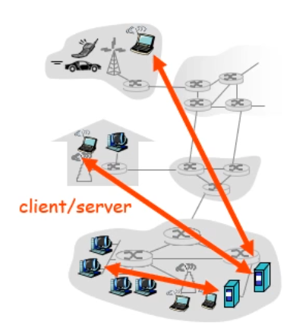

* Pure P2P architecture
  + No always-on server
  + Arbitrary end systems directly comm
  + Peers are intermittently connected and change IP addresses
  + Highly scalable but difficult to manage

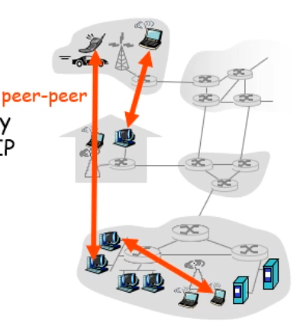

* Hybrid of client-server and P2P
  + Skype
    - Voice-over-IP P2P app
    - Centralised server: finding address of remote party
    - Client-client connection: direct (not through server)
  + Instant messaging
    - Chatting between two users is P2P
    - Centralised service: client presence detection/location
      * User registers its IP address with central server when it comes online
      * User contacts central server to find IP addresses of buddies
* Porcoesses communicating
  + Processes are programs currently running within host
    - Within same host, two processes comm using inter-process comm
    - Processes in diff hosts comm by exhanching messages
    - Client process: process that initiates communication
    - Server process: process that waits to be connected
* Sockets
  + Process sends/receives messages to and from its socket
  + Socket is like a door
    - Sending process shoves message out door
    - Sending process relies on transport infrastructure on other side of door which brings message to socket at receiving process

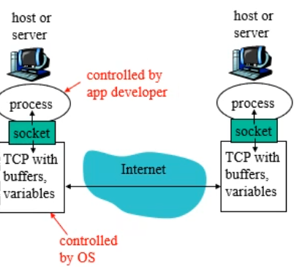

* Addressing processes
  + To receive msgs, process must have identifier
  + Host device has unique 32-bit IP address
  + Many processes can be running on same host so can’t use IP address of host on which process runs for identifying the process
  + Identifier includes both IP address and port numbers assoc with process on host
  + Example port numbers
    - HTTP server: 80
    - Mail server: 25
    - For sending HTTP message to www.cs.stir.ac.uk
      * IP address: 139.153.254.70
      * Port number: 80
* App-layer protocol defines
  + Types of messages exchanged
    - Request response
  + Message syntax
    - What fields in messages and how they are delineated
  + Message semantics
    - Meaning of info in fields
  + Rules for when and how processes send and respond to messages
  + Public-domain protocols
    - Defined in RFCs
    - Allows for interoperability
    - E.g. HTTP, SMTP
  + Proprietary protocols:
    - E.g. Skype
* What transport service does app need
  + Data loss
    - Some apps like audio can tolerate some loss
    - Other apps like file transfer require reliable transfer
  + Timing
    - Some apps like interactive games or internet need low delay to be effective
  + Throughput
    - Some apps like multimedia require minimum amount of throughput to be effective
    - Other apps (@elastic apps”) make use of whatever throughput they get
  + Security
    - Encryption, data integrity

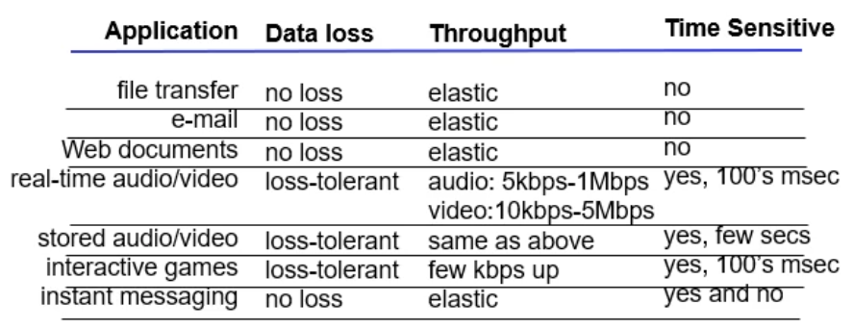

* Internet transport protocols services
  + TCP
    - Connection oriented – setup required between client and server processes
    - Reliable transport – between sending and receiving process
    - Flow control – sender won’t overwhelm receiver
    - Congestion control – throttle sender when network overloaded
    - Doesn’t provide: timing, min throughput guarantees, security
  + UDP
    - Unreliable data transfer
    - Doesn’t provide connection setup, reliability, flow control, security, congestion control, timing or throughput guarantee

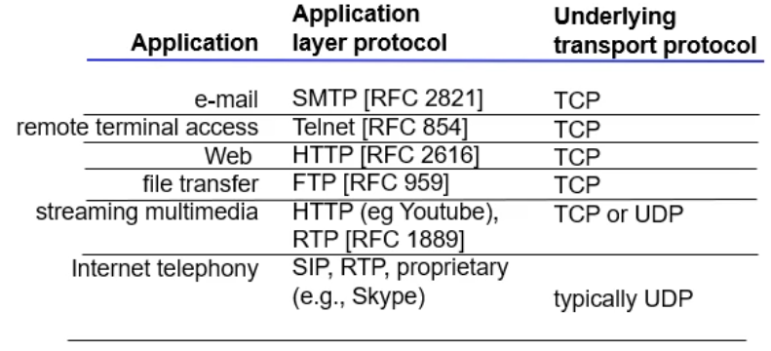

## Web/HTTP

* Web and HTTP
  + Web page consists of objects
  + Object can be HTML file, JPEG image, etc.
  + Web page consists of base HTML-file which includes several referenced objects
  + Each object addressable by URL
  + URL has a host name and a path name
* HTTP overview
  + Web’s app layer protocol
  + Client/server model
    - Client: browser that requests, receives, displays web objects
    - Server: web server, sends objects in response to requests
  + Uses TCP
    - Client makes TCP connection to server, port 80
    - Server accepts TCP conn from client
    - HTTP messages exchanged between browser and Web server
    - TCP conn closed
  + HYYP is stateless
    - Server maintains no info about past client requests
  + Protocols that maintain “state” are complex
    - Past history must be maintained
    - If server/client crashes, their views of “state” may be inconsistent, must be reconciled
* HTTP connections
  + Nonpersistent: at most one object is sent over TCP connection

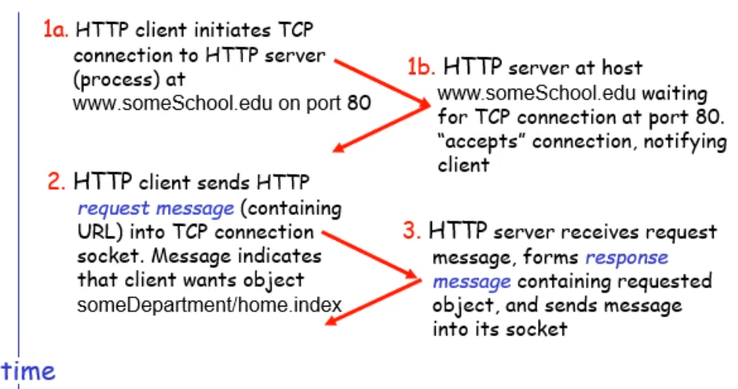

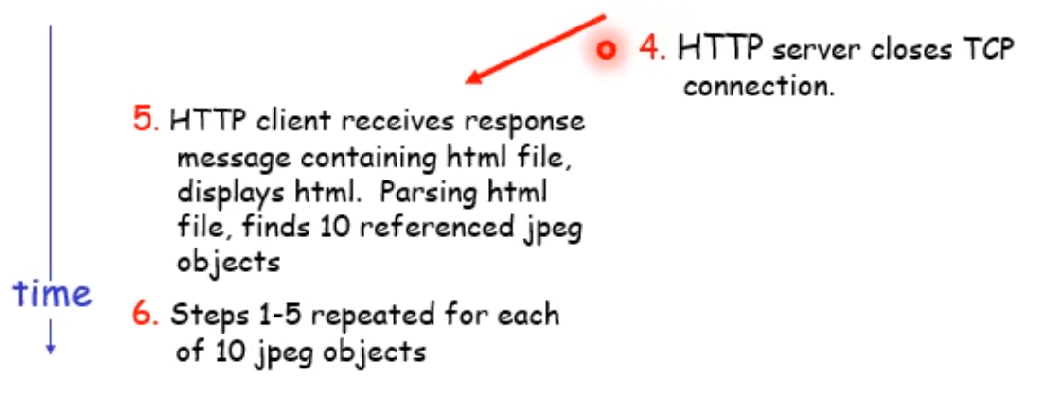

* + - Definition of Round Trip Time: time for small packet to travel from client to server and back
    - Response time
      * One RTT to initiate TCP connection
      * One RTT for HTTP request and first few bytes of HTTP response to return
      * File transmission time
    - Total = 2RTT+transmit time
  + Persistent: multiple objects can be sent over single TCP conn between client and server
    - Nonpersistent HTTP issues
      * Requires 2 RTTs per object
      * OS overhead for each TCP connection
      * Browsers often open parallel TCP connections to fetch referenced objects
    - Persistent HTTP
      * Server leaves connection open after sending response
      * Subsequent HTTP messages between same client/server sent over open connection
      * Client sends requests as soon as it encounters a referenced object
      * As little as one RTT for all referenced objects
* HTTP request message
  + Two types: request and response
    - Request

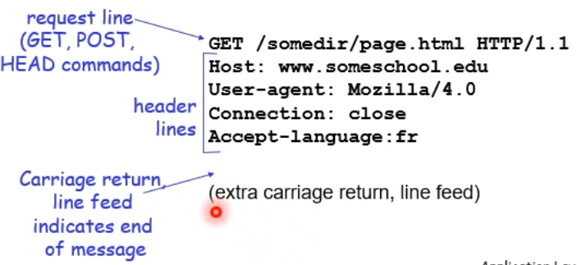

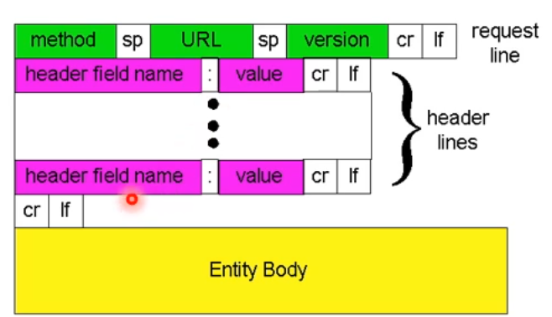

* + - Response

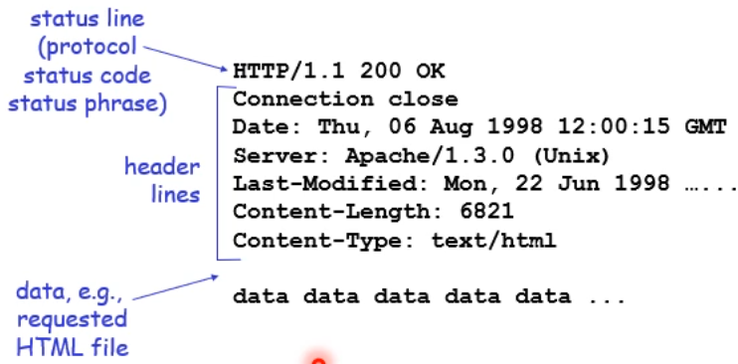

* HTTP status codes
  + 200 OK
  + 301 moved permanently
  + 400 bad request
  + 404 not found
  + 505 HTTP version not supported
* User-server state: cookies
  + Many major web sites use cookies
  + Four components
    - Cookie header line of HTTP response message
    - Cookie header line HTTP request message
    - Cookie file kept on user’s host, managed by user’s browser
    - Back-end database at web site

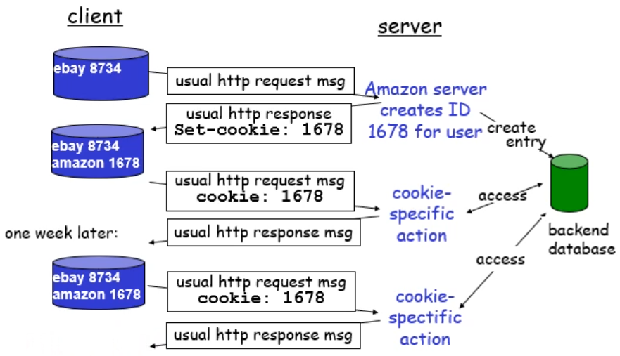

* + Cookies can bring
    - Authorization
    - Shopping carts
    - Recommendations
    - User session states
  + How to keep state
    - Protocol endpoints: maintain state at sender/receiver over multiple transactions
    - Cookies: http messages carry state
* Web caches (proxy server)
  + Goal: speed up response
  + Tactic: satisfy client request without involving origin server
  + User sets browser – web access via cache
  + Browser sends all HTTP requests to cache
    - Object in cache: cache returns object
    - Else cache requests object from origin server, then returns to client

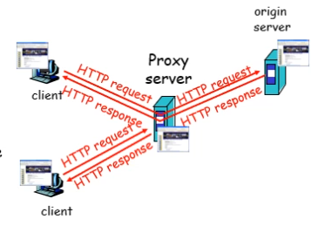

* + Cache acts as both client and server
  + Typically, cache is installed by ISP (university, company, residential ISP)
  + Why web caching?
    - Reduced response time for client request
    - Reduced traffic on institution’s access link
    - Internet dense with caches enables “poor” content providers to effectively deliver content
* Conditional GET
  + Don’t send object if cache has up-to-date cached version
  + Cache: specify date of cached copy in HTTP request
  + Server: response contains no object if cached copy up-to-date

## DNS

* What is DNS
  + One of the core internet protocols
  + Routing and DNS are the most important infrastructure protocols as without them nothing else would work
  + DNS provides:
    - Mapping from names to addresses
    - Mechanism to store and retrieve info in global data store
* DNS Data Model
  + Loosely consistent delegated database
  + Delegated 🡪 contents under loal control
  + Loosely consistent 🡪 share info (with constraints)
    - Doesn’t need to match or be up to date
    - Operation global with owners of “names” responsible for serving up their own data
  + Data on wire is binary
  + Domain names case insensitive
* Domain NameSystem
  + Internet hosts, routers identification:
    - IP address used for addressing datagrams
    - “name” e.g. used by humans
  + Domain Name System
    - Distributed database implemented in hierarchy of many name servers
    - App-layer protocol hosts and name servers to comm to resolve names (Address/name translation)
* DNS
  + DNS services
    - Hostname to IP address translation
    - Host aliasing
      * Canonical, alias names
    - Mail server aliasing
    - Load distribution
      * Replicated web servers: set of IP addresses for one canonical name
  + DNS is not
    - A directory service
      * No way to search database (and not easy to add this functionality)
    - Why not centralise DNS?
      * Single point of failure
      * Traffic volume
      * Distant centralised database
      * Maintenance
      * Doesn’t scale
* Distributed, hierarchical database

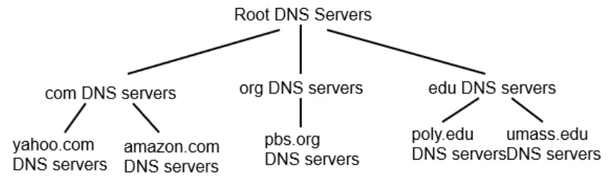

* + Client wants IP for [www.amazon.com](http://www.amazon.com)
    - Client queries a root server to find .com DNS server
    - Client queries .com DNS server to get amazon.com DNS server
    - Client queries amazon.com DNS server to get IP address for [www.amazon.com](http://www.amazon.com)
* DNS: Root name server
  + Contacted by local name server that can not resolve name
  + Root name server:
    - Contacts authoritative name server if name mapping not known
    - Gets mapping
    - Returns mapping to local name server
    - 13 root name servers worldwide
* TLD and Authoritative Servers
  + Top-level domain servers
    - Responsible for com, org, net, edu, and country domains
    - Network Solutions maintains servers for .com TLD
  + Authoritative DNS servers
    - Org’s DNS servers, providing authoritative hostname to IP mappings for org servers (e.g. Web, mail)
    - Can be maintained by org or service provider
* Local name server
  + Doesn’t strictly belong to hierarchy
  + Each ISP has one
    - Also called “default name server”
  + When host makes DNS query, it is sent to its local DNS server
    - Acts as proxy, forwards query into hierarchy
* DNS name resolution example

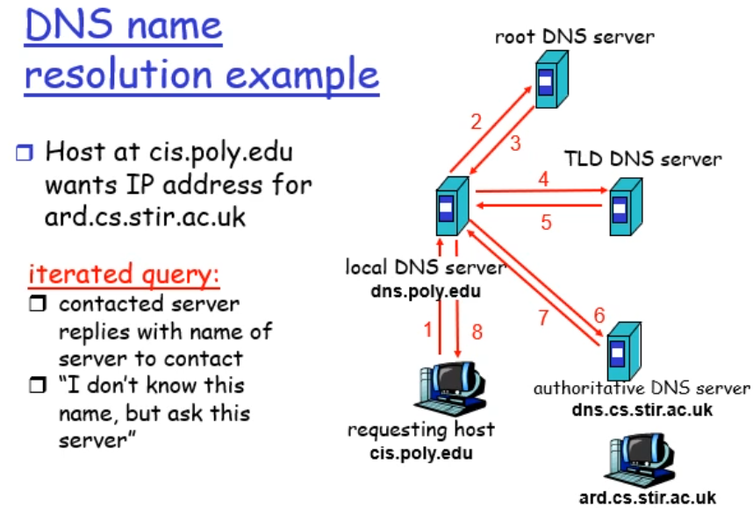

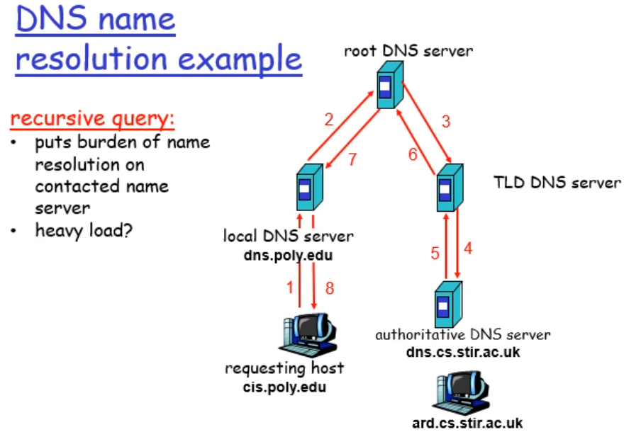

* DNS: caching and updating records
  + Once name server learns mapping, it caches mapping
    - Cache entries timeout after some time
    - TLD servers typically cached in local name servers
      * Thus root name servers not often visited
* DNS records
  + DNS stores resource records (RR)
  + **RR format**: (name, value, type, ttl)
  + Type A
    - **name** is hostname
    - **value** is IP address
  + Type CNAME
    - **name** is alias name for some “canonical” name
    - **value** is canonical name
  + Type NS
    - **name** is domain (e.g. stir.ac.uk)
    - **value** is hostname of authoritative name server for this domain
  + Type MX
    - **value** is name of mailserver associated with name
* DNS protocol, messages
  + DNS protocol: query and reply messages, both with some message format
  + msg header
    - identification: 16 bit # for query, reply to query uses same #
    - flags
      * query or reply
      * recursion desired
      * recursion available
      * reply is authoritative

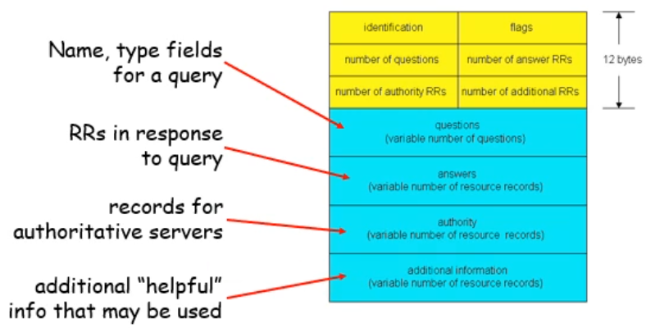

* Inserting records into DNS

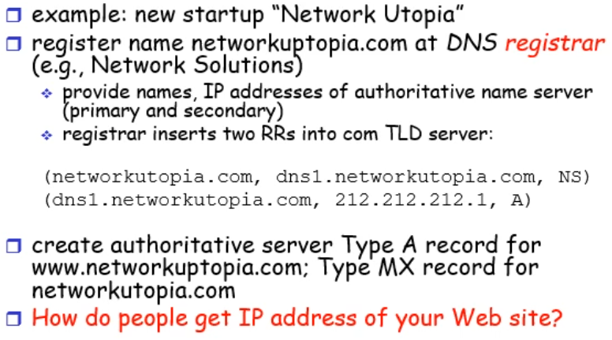

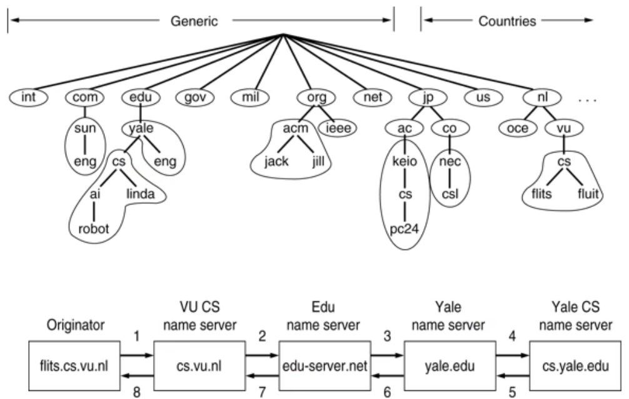

# Transport Layer

## Introduction

* Transport services and protocols
  + Provide logical comm between app processes running on different hosts
  + Transport protocols run in end systems
    - Send side: breaks app messages into segments, passes to network layer
    - Rcv side: reassembles segments into messages, passes to app layer
  + More than one transport protocol available to apps
    - Internet: TCP and UDP
* Transport vs network layer
  + Network layer: logical comm between hosts
  + Transport: logical comm between processes
    - Relies on, enhances, network layer services
* Internet transport-layer protocols
  + Reliable, in-order delivery (TCP)
    - Congestion and flow control
    - Connection setup
  + Unreliable, unordered delivery
    - No-frills extension of “best-effort” IP
  + Services not available
    - Delay guarntees
    - Bandwidth guarantees
  + Transport layer protocols implemented on hosts only
    - Network layer protocol implemented on router components in network and hosts
* Transport layer outline
  + Transport layer services
  + Multiplexing and demultiplexing
  + Connectionless transport: UDP
  + Principles of reliable data transfer
  + Connection-oriented transport: TCP
    - Segment structure
    - Reliable data transfer
    - Flow control
    - Connection management
  + Principles of congestion control
  + TCP congestion control
* Muliplexing/demultiplexing
  + Demultiplexing at rcv host
    - Delivering received segments to correct socket
  + Multiplexing at send host
    - Gathering data from multiple sockets, enveloping data with header (later used for demultiplexing)

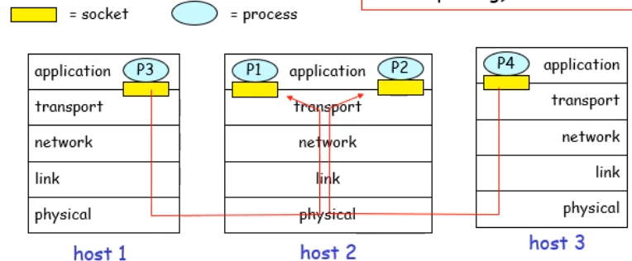

* How demultiplexing works
  + Host receives IP datagrams
    - Each datagram has source IP address, destination IP address
    - Each datagram carries 1 transport-layer segment
    - Each segment has source, destination port number
  + Host uses IP addresses & port numbers to direct segment to appropriate socket

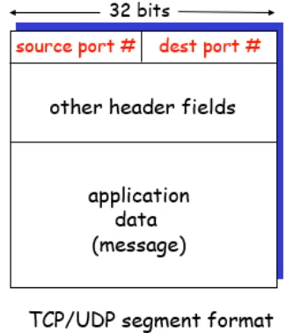

* Connectionless demultiplexing
  + Create sockets with port numbers
  + UDP socket identified by two-tuple
    - dest IP addr
    - dest port number
  + When host receives UDP segment
    - Checks destination port number in segment
    - Directs UDP segment to socket with that port number
  + IP datagrams with diff source IP addr and/or source port numbers can be directed to same socket
* Connection-oriented demultiplexing
  + TCP socket identified by 4-tuple
    - Source IP addr
    - Source port number
    - Dest IP addr
    - Dest port number
  + Recv host uses all four values to direct segment to appropriate socket
  + Server host may support many simult. TCP sockets
    - Each socket ID’d by its own tuple
  + Web servers have diff sockets for each connection client
* UDP: User Datagram Protocols
  + Barebones internet transport protocol
  + Best effort service, UDP segments may be lost or deloivered out of order to app
  + Connectionless
    - No handshaking between UDP sender, receiver
    - Each UDP segment handled independently of others
  + Why is there a UDP
    - No connection establishment to add delay
    - Simple: no connection state at sender, receiver
    - Small segment header
    - No congestion control so UDP can go as fast as needed
  + Often used for multimedia apps
    - Loss tolerant and rate sensitive
  + Other uses
    - DNS
    - SNMP
  + Reliable transfer over UDP: add reliability at app layer
    - App-specific error recovery

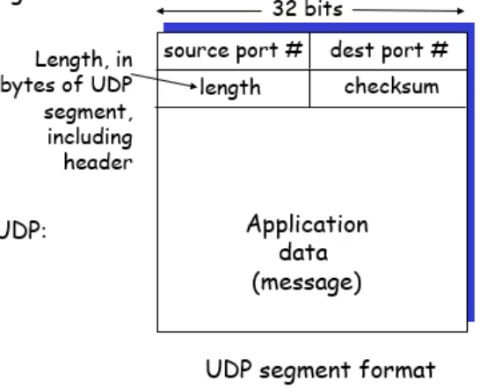

* UDP checksum
  + Detect errors like flipped bts in transmitted segment
  + Sender
    - Treat segment contents as sequence of 16-bit integers
    - Checksum: addition (1’s complement sum) of segment contents
    - Sender puts checksum val into UDP checksum field
  + Receiver
    - Compute checksum of received segment
    - Check if computed checksum equals checksum field value
      * No – error detected
      * Yes – no error detected but maybe errors nonetheless?
  + Example

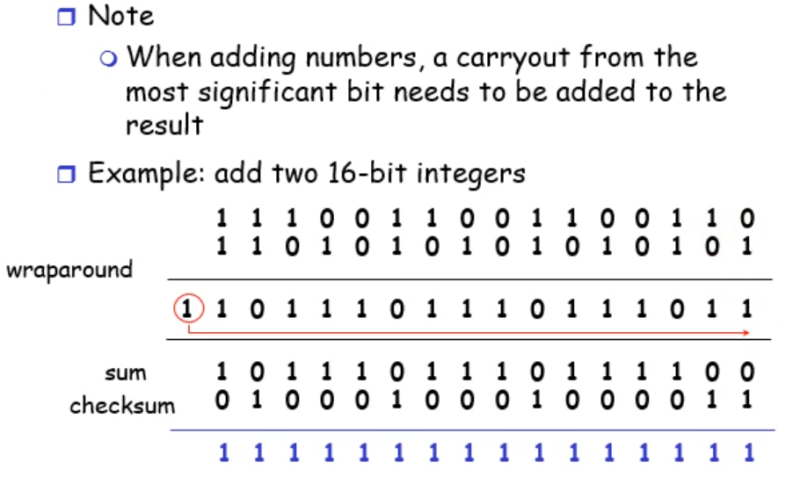

## RDTP 1

* Principles of reliable data transfer
  + Important in app, transport, link layers
  + Characteristics of unreliable channel will determine complexity of reliable data transfer protocol (rdt)

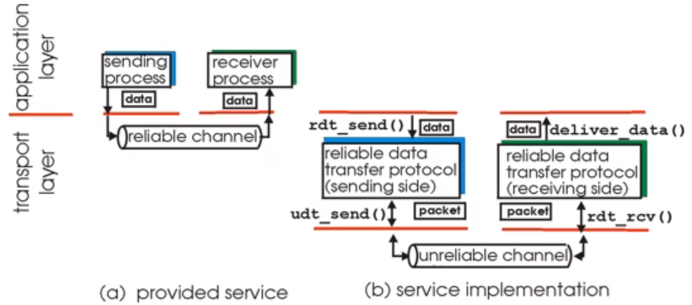

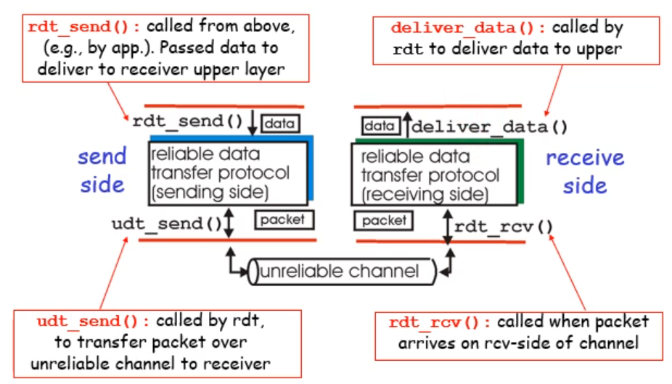

* Getting started
  + We’ll
    - Incrementally develop sender, receiver sides of reliable data transfer protocol (rdt)
    - Consider only unidirectional data transfer
      * But control info will flow on both directions!
    - Use finite state machines (FSM) to specify sender, receiver

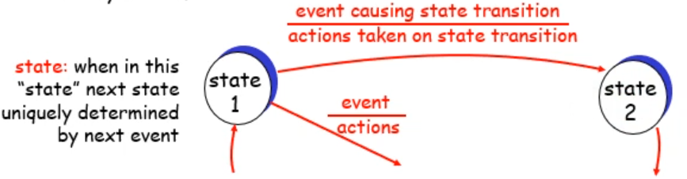

* Rdt1.0: Reliable transfer over reliable channel

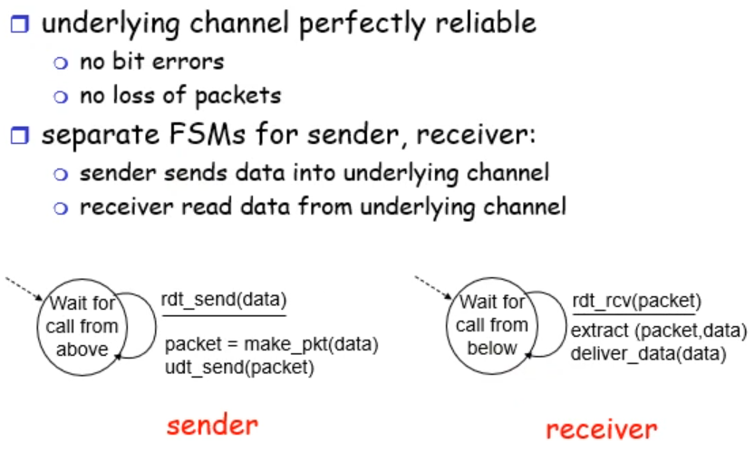

## RDTP 2

* Rdt2.0: channel with bit errors
  + Underlying channel may flip bits in packet
    - Checksum to detect bit errors
  + How to recover from errors:
    - Acknowledgements (ACKs): receiver explicitly tells sender that pkt received OK
    - Negative acknowledgements (NAKs): receiver explicitly tells sender that pkt had errors
    - Sender retransmits pkt on receipt of NAK
  + New mechanisms in rdt2.0 (beyond rdt1.0)
    - Error detection
    - Reciver feedback: control msgs (ACK, NAK) rcvr🡪sender
* Rdt2.0 fatal flaw
  + If ACK/NAK corrupted
    - Sender doesn’t know what happened at receiver
    - Can’t just retransmit: might duplicate
  + Handling duplicates
    - Sender retransmits current pkt if ACK/NAK garbles
    - Sender adds sequence number to each pkt
    - Receiver discards supplicate pkt
    - Stop and wait: sender sends one packet then waits for receiver response
* Rdt2.1: discussion
  + Sender
    - Seq # added to pkt
    - Two seq #’s (0,1) will suffice
    - Must check if received ACK/NAK corrupted
    - Twice as many states
      * State must remember whether current pkt has 0 or 1 seq #
  + Receiver
    - Must check if received packet is duplicate
      * State indicates whether 0 or 1 expected pkt seq #
    - Receiver cannot know if its last ACK/NAK received OK at sender
* Rdt2.2: a NAK-free protocol
  + Same functionality as 2.1, using ACKs only
  + Instead of NAK, receiver sends ACK for last pkt received OK
    - Receiver must explicitly include seq # of pkt being ACKed
  + Duplicate ACK at sender results in same action as NAK: retransmit current pkt

## RDTP 3

* Rdt3.0: channels with errors and loss
  + New assumption
    - Underlying channel can also lose packets (data or ACKs)
      * Checksum, seq #, ACKs, retransmissions will help but not enough
  + Approach: sender waits reasonable amount of time for ACK
    - Retransmits if no ACK received in this time
    - If pkt (or ACK) just delayed (not lost)
      * Retransmission will be duplicate, but use of seq #’s already handles this
      * Receiver must specify seq # of pkt being ACKed
    - Requires countdown timer
* Performance of rdt3.0
  + Works, but poor performance
  + Sender has to wait
  + Example

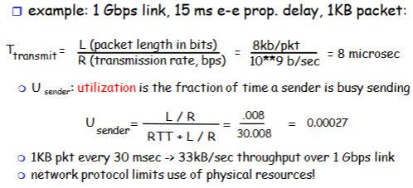

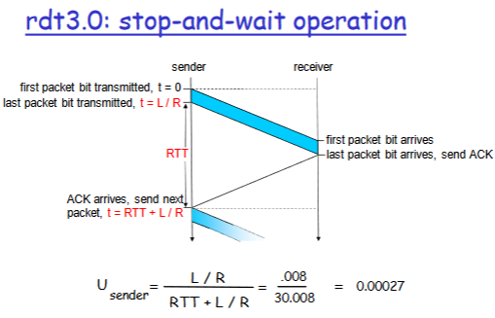

* Pipelined protocols
  + Pipelining: sender allows multiple, in-flight, yet to be acknowledged pkts
    - Range of sequence numbers must be increased
    - Buffering at sender and/or receiver
  + Two generic forms of pipelined protocols: go-Back-N, selective repeat

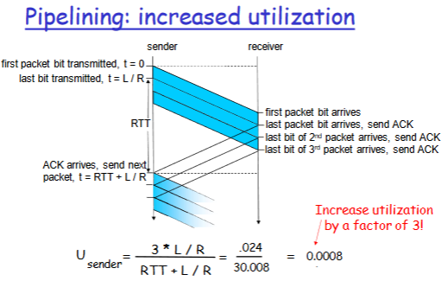

* Go-Back-N

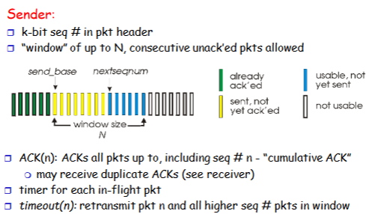

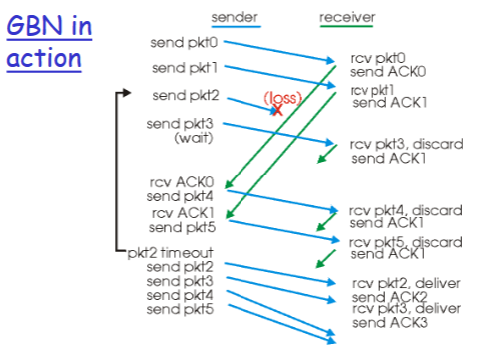

* Selective Repeat
  + Receiver individually acknowledges all correctly received pkts
    - Buffers pkts, as needed, for eventual in-order delivery to upper layer
  + Sender only resends pkts for which ACK not received
    - Sender timer for each unACKed pkt
  + Sender window
    - N consecutive seq #’s
    - Again limits seq #s of sent, unACKed pkts

## TCP 1

* Overview
  + Point to point
    - One sender and one receiver
  + Reliable in order byte stream
    - No “message boundaries”
  + Pipelined
    - TCP congestion and flow control set window size
  + Send & receive buffers
  + Full duplex data
    - Bi-directional data flow in same connection
    - MSS: max segment size
  + Connection oriented
    - Handshaking inits sender, receiver state before data exchange
  + Flow controlled
    - Sender will not overwhelm receiver
* TCP segment structure

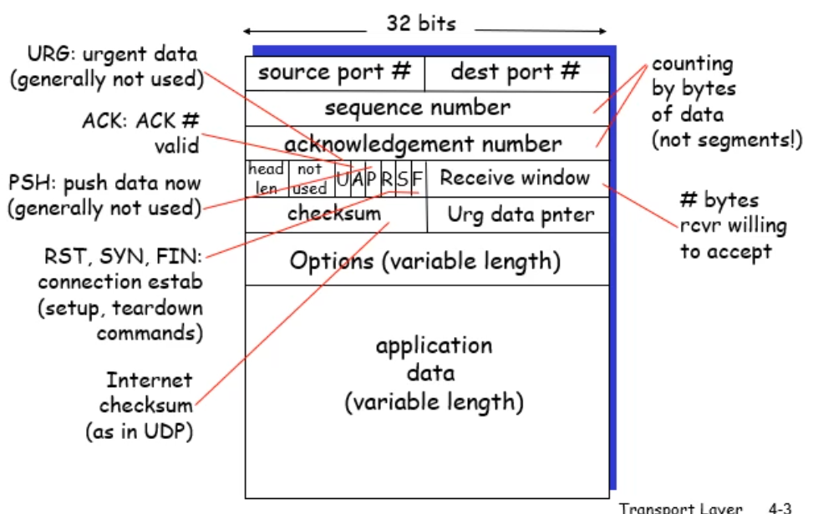

* TCP seq #’s and ACKs
  + Seq. #’s
    - Byte stream “number” of first byte in segment’s data
  + ACKs
    - Seq # of next byte expected from other side
    - Cumulative ACK
  + Up to implementor to handle out-of-order segments, not receiver

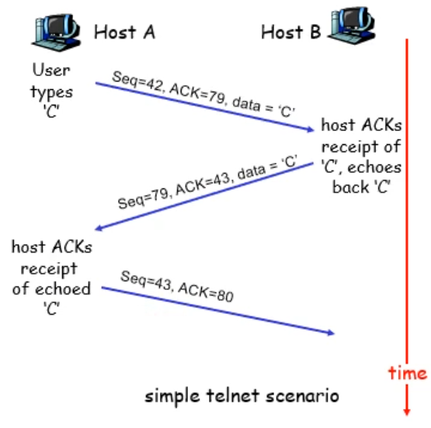

* TCP round trip time and timeout
  + How to set TCP timeout value
    - Longer than RTT
      * But RTT varies
    - Too short: premature timeout
      * Unnecessary retransmissions
    - Too long: slow reaction to segment loss
  + Estimating RTT
    - SampleRTT: measured time from segment transmission until ACK receipt
      * Ignore retransmisssions
    - SampleRTT will vary, want estimated RTT “smoother”
      * Average several recent measurements, not just current SampleRTT
  + EstimatedRTT = (1 – alpha) * CurrentEstimatedRTT + alpha * SampleRTT
    - Exponential weighted moving average
    - Typical alpha value is 0.125
    - Influence of past sample decreases exponentially fast
  + Setting timeout
    - EstimatedRTT plus “safety margin”
      * Large variation in EstimatedRTT -> larger safety margin
    - First estimate of how much SampleRTT deviates from EstimatedRTT
      * DevRTT = (1-beta)*DevRTT + beta*|SampleRTT-EstimatedRTT|
      * Typically beta is 0.25
      * Again, this favours history of the deviant value between sample and estimated RTT
      * TimeoutInterval = EstimatedRTT + 4*DevRTT
* TCP reliable data transfer
  + TCP created rdt service on top of IP’s unreliable service
  + Pipelined segments
  + Cumulative acks
  + TCP uses single retransmission timer
  + Retransmissions triggered by
    - Timeout events
    - Duplicate acks
  + Initially consider simplified TCP sender
    - Ignore duplicate acks
    - Ignore flow control, congestion control
* TCP sender events
  + Data rcvd from app
    - Create segment with seq #
    - Seq # is byte-stream number of first data byte in segment
    - Start timer if not already running
    - Expiration interval: TimeoutInterval
  + Timeout
    - Retransmit segment that caused timeout
    - Restart timer
  + Ack rcvd
    - If acknowledges previously unacked segments
      * Update what is known to be acked
      * Start timer if there are outstanding segments
* TCP: retransmission scenarios

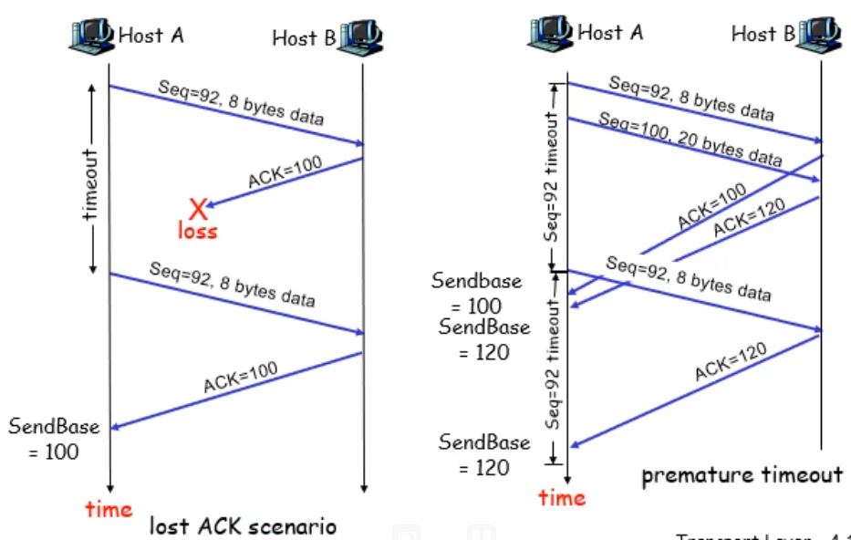

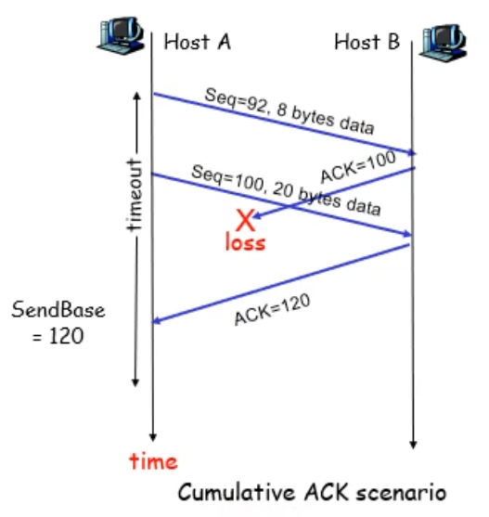

* TCP ACK generation

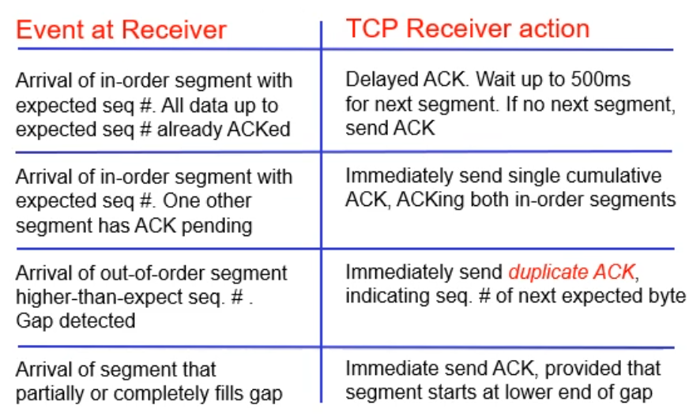

* Fast retransmit
  + Timeout period often relatively long
    - Long delay before resending lost packet
  + Detect lost segments via duplicate ACKs
    - Sender often sends many segments back-to-back
    - If segment lost, there will likely be many duplicate ACKs
  + If sender receives 3 ACKs for the same data, it supposes that segment after ACKed data was lost:
    - Fast retransmit: resend segment before timer expires
* TCP flow control
  + Receive side of TCP connection has a receive buffer

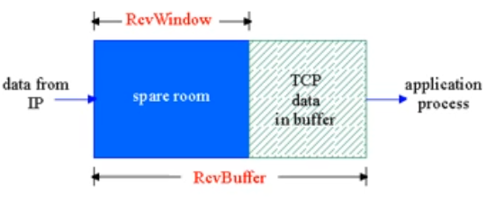

* + App process may be slow at reading from buffer
  + Flow control: sender won’t overflow receiver’s buffer by transmitting too much too fast
  + Speed-matching service: matching the send rate to the receiving app’s drain rate
* TCP Flow control: how it works
  + (assume TCP receiver discards out of order segments)
  + Spare room in buffer
    - =RcvWindow
    - =RcvBuffer-[LastByteRcvd-LastByteRead]
  + Rcvr advertises spare room by including value of RcvWindow in segments
  + Sender limits unACKed data to RcvWindow
    - Guarantees receive buffer doesn’t overflow

## TCP 2

* Principles of congestion control
  + Congestion
    - Too many sources sending too much data too fast for network to handle
    - Different from flow control, problem in network itself
    - Manifestations
      * Lost packets (buffer overflow at routers)
      * Long delays (queuing in router buffers)
    - Top-10 problem
* Causes/costs of congestion: scenario 1

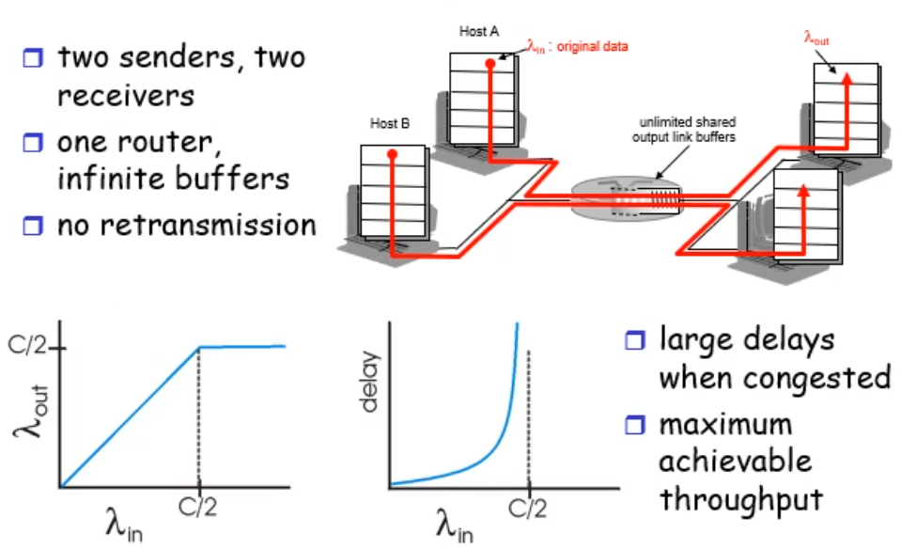

* Scenario 2

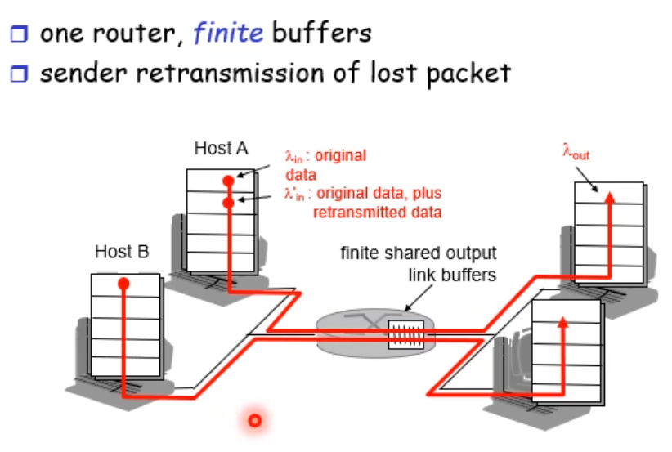

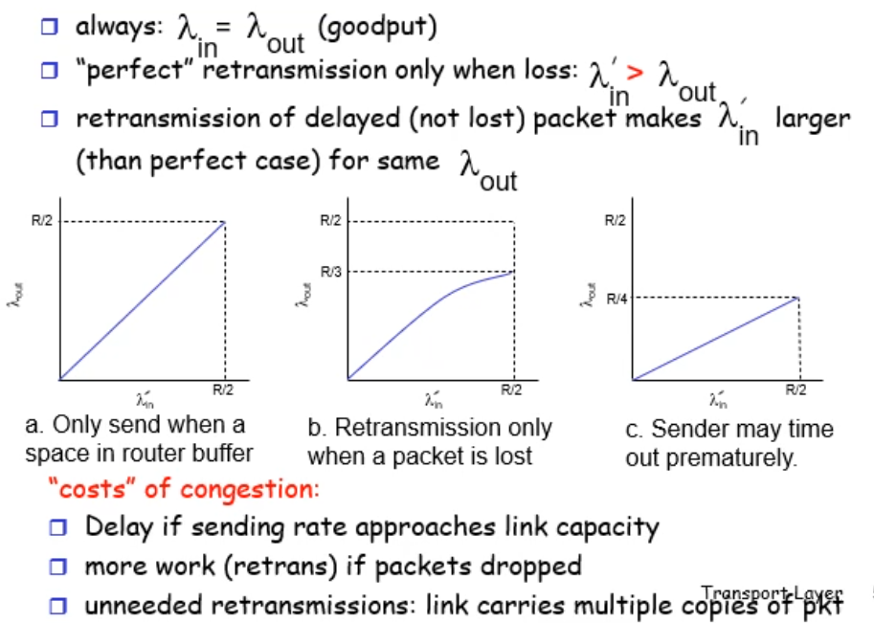

* + Costs of congestion
    - Delay if sending rate approached link capacity
    - More work (retrans) if packets dropped
    - Unneeded retransmissions: link carries multiple copies of pkt
* Scenario 3

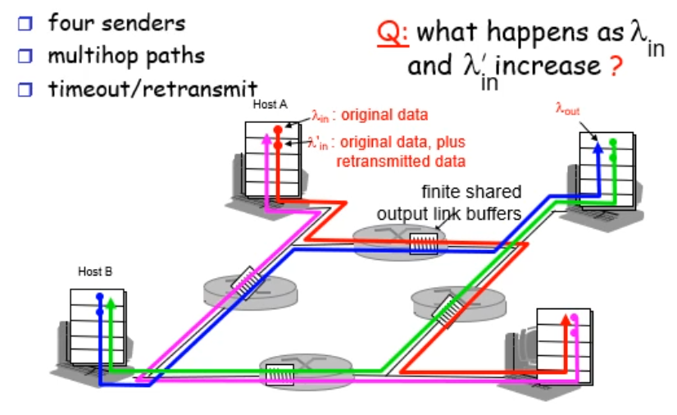

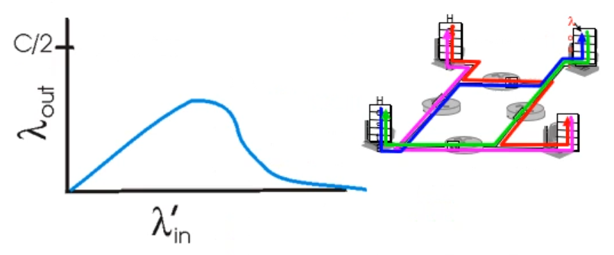

* + Another cost of congestion
    - When packet dropped, any upstream transmission capacity used for that packet was wasted
* Approached towards congestion control
  + End-end congestion control
    - Approach taken by TCP
    - No explicit feedback from network
    - Congestion inferred from end-system observed loss, delay
  + Network-assisted congestion control
    - Routers provide feedback to end systems
      * Single bit indicating congestion (SNA, DECbit, TCP/IP ECN, ATM)
      * Explicit rate sender should send at
* TCP congestion control
  + Approach
    - Increase transmission rate (window size), probing for usable bandwidth, until loss occurs
    - Additive increase – increase CongWin by 1 MSS every RTT until loss detected
    - Multiplicative increase – cut CongWin in half after loss

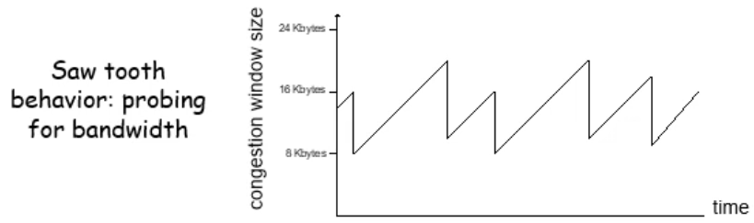

* + Sender limits transmission
    - **LastByteSent-LastByteAcked <= CongWin**
  + Roughly
    - **Rate = (CongWin/RTT) bytes/sec**
  + CongWin is dynamic, function of perceived network congestion
  + How does sender perceive congestion?
    - Loss event = timeout of 3 duplicate acks
    - TCP sender reduces rate (CongWin) after loss event
* TCP slow start
  + When connection begins, increase rate exponentially until first loss event
    - Double CongWin every RTT
    - Done by incrementing CongWin for every ACK received
  + Summary: initial rate is slow but ramps up exponentially fast
* Summary
  + When CongWin below Threshold, sender in slow-start phase, window grows exponentially
  + When CongWin above Threshold, sender is in congestion-avoidance phase, window grows linearly
  + When triple duplicate ACK occurs, Threshold set to CongWin/2 and CongWin set to Threshold
  + When timeout occurs, Threshold set to CongWin/2 and CongWin is set to 1 Message Segment Size

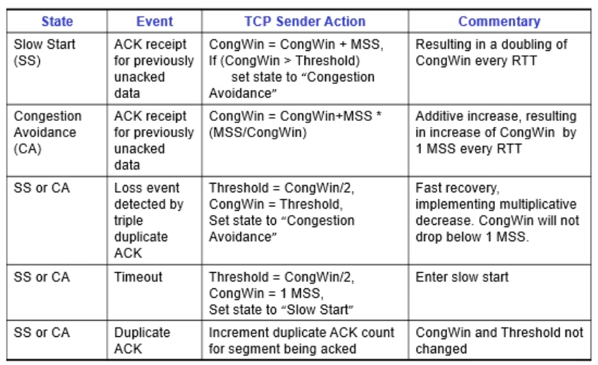

# Routing

## Network Layer Introduction

* Network layer
  + Transport segment from sending to receiving host
  + On sending side encapsulates segments into datagrams
  + On receiving side, delivers segments to transport layer
  + Network layer protocols in every host, router
  + Router examines header fields in all IP datagrams passing through it
* Two key network-layer functions
  + Forwarding – move packets from router’s input to appropriate router output
    - Like process of getting through single junction
  + Routing – determine route taken by packets from source to destination
    - Like process of planning trip from source to destination
    - Routing algorithms
* Connection setup
  + 3rd important function in some network architectures
    - ATM, frame relay, X.25
  + Before datagrams flow, two end hosts and intervening routers establish virtual connection
    - Routers involved
  + Network vs transport layer connection service:
    - Network – between two hosts (may also involve intervening routers in case of VCs)
    - Transport – between two processes
* Network service model
  + Example services for individual datagrams
    - Guaranteed delivery
    - Guaranteed delivery with less than 40 msec delay
  + Example services for a flow of datagrams
    - In-order datagram delivery
    - Guaranteed min bandwidth to flow
    - Restrictions on changes in inter-packet spacing

## Virtual Circuits & Datagram Networks

* Network layer connection & connection-less service
  + Datagram network provides network-layer connectionless service
  + VC network provides network-layer connection service
  + Analogous to transport-layer services but:
    - Service: host-to-host
    - No choice: network provides one or the other
    - Implementation: in network core
* Virtual circuits
  + Source to dest path behaves much like telephone circuit
  + Call setup for each call before data can flow
  + Each packet carries VC identifier
  + Every router on source-dest path maintains “state” for each passing connec
  + Link, router resources (bandwidth, buffers) may be allocated to VC (dedicated resources = predictable service)
* VC implementation
  + VC consists of
    - Path from source to destination
    - VC numbers, one for each link along path
    - Entries in forwarding tables in routers along path
  + Packet belonging to VC carries VC no. rather than destination addr.
  + VC number can be changed one each link
    - New VC no. from forwarding table
  + Routers maintain connection state info
* VC signalling protocols
  + Used to setup maintain and teardown VC
  + Used in ATM, frame-relay, X.25
  + Not used in internet

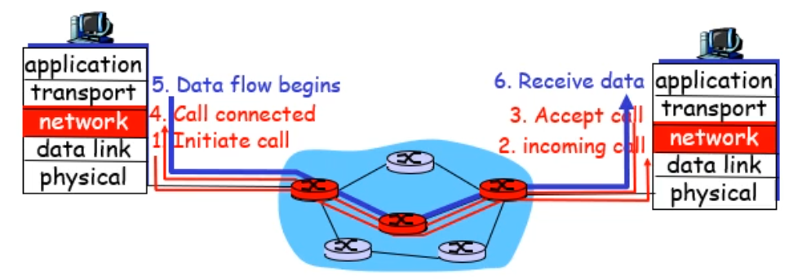

* Datagram networks
  + No call setup at network layer
  + Routers: no state about end-to-end connections
    - No network-level concept of “connection”
  + Packets forwarded using destination host addr.
    - Packets between same source-dest pair may take diff paths
* Datagram or VC network
  + Internet (datagram)
    - Data exchange among computers
      * “elastic” service, no strict timing reqs.
    - Smart end systems
      * Can adapt, perform control, error recovery
      * Simple inside network, complexity at “edge”
    - Many link types
      * Different characteristics
      * Uniform service difficult
  + ATM (VC)
    - Evolved from telephony
    - Human conversation
      * Strict timing, reliability requirements
      * Need for guaranteed service
    - Dumb end systems
      * Telephones
      * Complexity inside network

## IPv4 Introduction

* Internet network layer

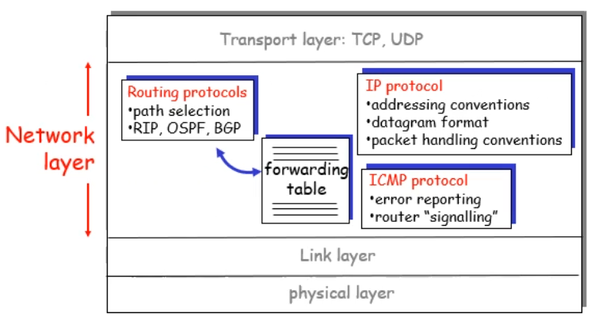

* IP datagram format

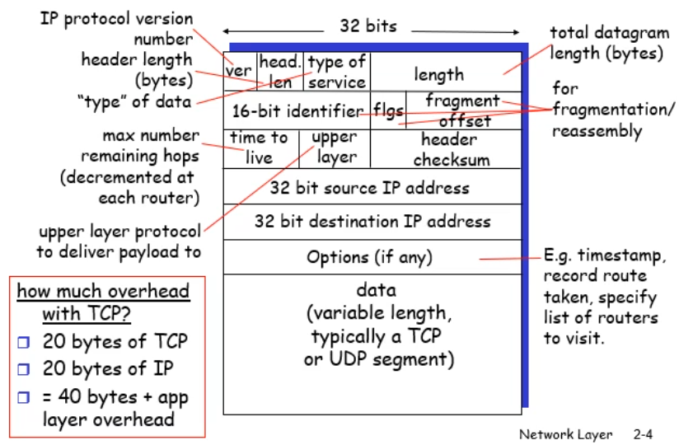

* IP Fragmentation & reassembly
  + Network lnks have MTU(max transfer size) – largest possible link-level frame
    - Diff link types, diff MTUs
  + Large IP datagram divided(fragmented) within net
    - One datagram becomes several datagrams
    - Reassembled only at destination
    - IP header bits used to identify & order related fragments

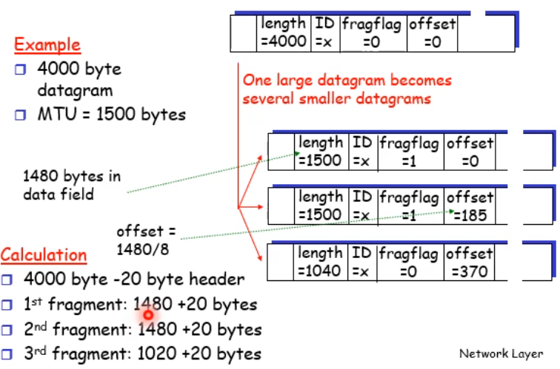

## IPv4 Addressing

* IP Addressing
  + IP address – 32bit identifier for host, router interface
  + Interface – connection between host/router and physical link
    - Routers typically have multiple interfaces
    - Host typically has one interface
    - IP addresses associated with each interface
* Subnets
  + Ip addr
    - Subnet part (high order bits)
    - Host part (low order bits)
  + What’s a subnet
    - Device interfaces with same subnet part of IP addr
    - Can physically reach each other without intervening router
  + Recipe
    - To determine subnets, deatach each interface from its host or router, creating islands of isolated networks – each isolated network is called a subnet
    - 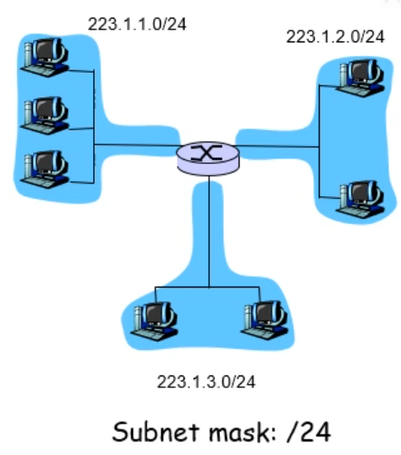
* IP Addressing: CIDR
  + CIDR – Classless InterDomain Routing
    - Subnet poirtion of address of arbitrary length
    - Addr format: a.b.c.d/x where x is # bits in subnet portion of address
    - 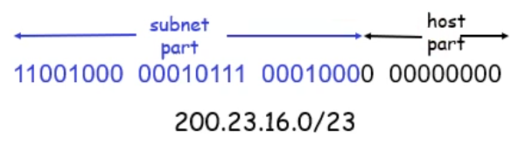
* How to get IP address
  + Hard coded by system admin in a file
  + DHCP: Dynamic Host Configuration Protocol – dynamically get address from a server
    - “plug and play”
* DHCP
  + Goal – allow host to dynamically obtain its IP address from network server when it joins network
    - Can renew its lease on address in use
    - Allows reuse of addresses (only hold address while connected and “on”
    - Support for mobile users who want to join network (more shortly)
  + DHCP overview:
    - Host broadcasts “DHCP discover” message
    - DHCP server responds with “DHCP offer” message
    - Host requests IP address: “DHCP request” message
    - DHCP server sends address: “DHCP ack” message
    - 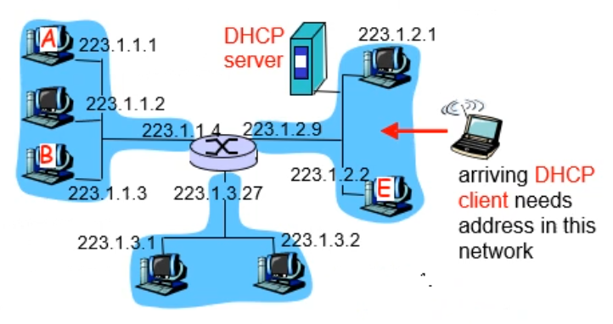
    - 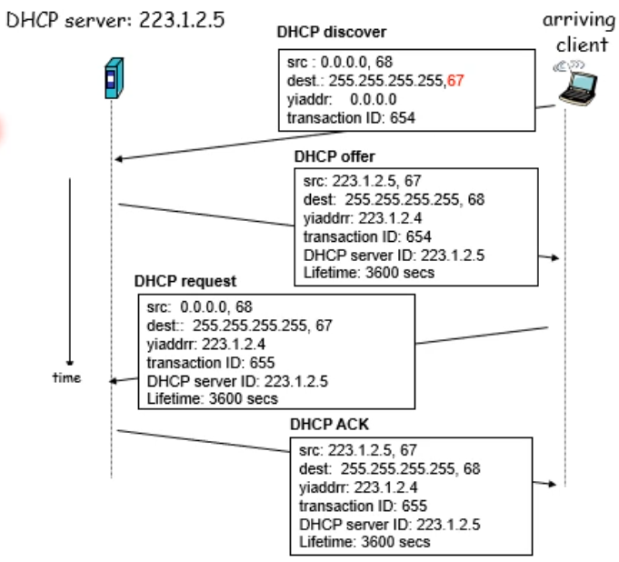
* How does network get subnet part of IP addr
  + Gets allocated portion of its provider ISP’s addr space
  + 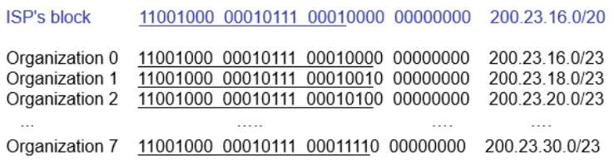
* Hierarchical addressing – route aggregation
  + Hierarchical addressing allows efficient advertisement of routing information
  + 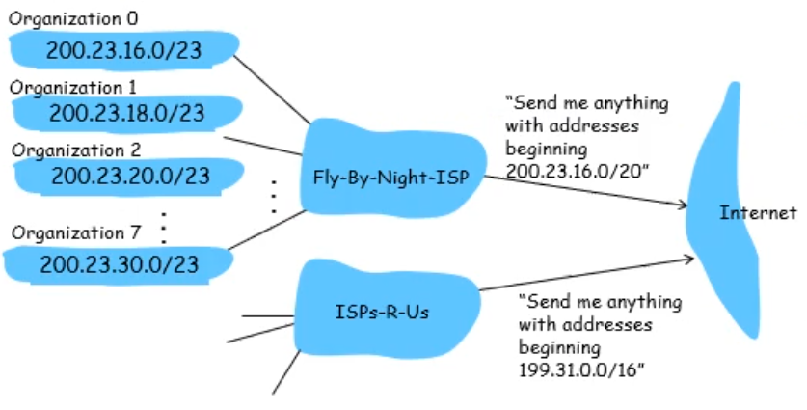
* How does ISP get block of addresses
  + ICANN – Internet Corporation for Assigned Names and Numbers
    - Allocates addresses
    - Manages DNS
    - Assigns domain names, resolves disputes

## NATs

* NAT – Network Address Translation
  + 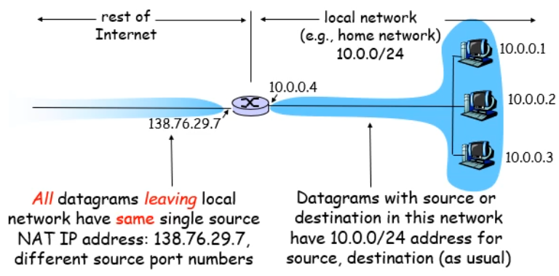
  + Motivation
    - Local network uses just one IP address as far as outside world concerned
      * Range of addresses not needed from ISP – just one IP address for all devices
      * Can change addresses of devices in local network without notifying outside world
      * Can change ISP without changing addresses of devices in local network
      * Devices inside local net not explicitly addressable, visible by outside world (a security plus)
  + Implementation
    - Outgoing datagrams – replace (source IP addr, port #) of every outgoing datagram to (NAT IP address, new port #)
      * Remote clients/servers will respond using (NAT IP addr, new port #) as destination addr.
    - Remember (in NAT translation table) every (source IP addr, port #) to (NAT IP addr, new port #) translation pair
    - Incoming datagrams – replace (NAT IP addr, new port #) in dest fields of every incoming datagram w/ corresponding (source IP addr, port #) stored in NAT table
  + 16-bit port-number field
    - 60,000 simultaneous connections with a single LAN-side addr
  + NAT is controversial
    - Routers should only process up to layer 3
    - Violates end-to-end argument
      * NAT possibility must be considered by app designers, e.g., P2P applications
    - Address shortage should instead be solved by IPv6
    - Note that NATs and firewalls are quite closely related concepts
  + NAT traversal problem
    - 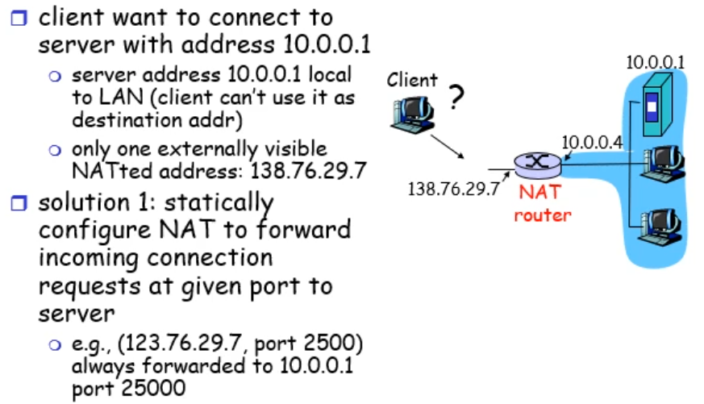
    - 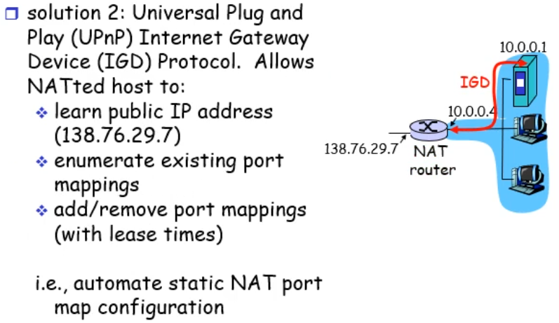

## ICMP & IPv6

* ICMP – Internet Control Message Protocol
  + Used by hosts & routers to communicate network-level information
    - Error reporting: unreachable host, network, port, protocol
    - Echo request/reply (used by ping)
  + Network-layer “above” IP
    - ICMP messages carried in IP datagrams
  + ICMP message: type, code plus first 8 bytes of IP datagram causing error
  + 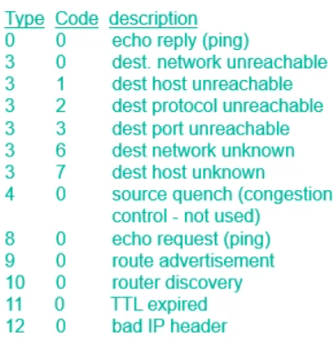
* Traceroute and ICMP
  + Source sends series of UDP segments to dest
    - First has TTL = 1
    - Second has TTL – 2
    - Etc
    - Unlikely port number
  + Whennth datagram arrives to nth router
    - Router discards datagram
    - And sends to source an ICMP message (type 11, code 0)
    - Message includes name of router & IP address
  + When ICMP message arrives, source calculates RTT
  + Traceroute does this 3 times
  + Stopping criterion
    - UDP segment eventually arrives at destination host
    - Destination returns ICMP “host unreachable” packet (type 3, code 3)
    - When source gets this ICMP, stops
* IPv6
  + Initial motivation: 32-bit addr space soon to be completely allocated
  + Additionally
    - Header format helps speed processing/forwarding
    - Header changes to facilitate QoS
    - IPv6 datagram format
      * Fixed-length 40 byte header
      * No fragmentation allowed
* IPv6 header
  + Priority: identify priority among datagrams in flow
  + Flow label: identify datagrams in same “flow” (concept of “flow” not well defined)
  + Next header: identify upper layer protocol for data
  + 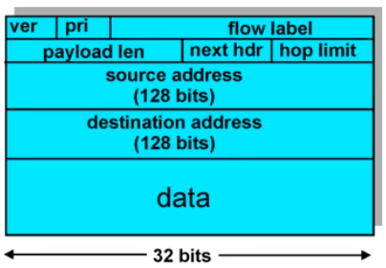
* Changes from IPv4
  + No checksum to reduce processing time each hop
  + Options – allowed, but outside of header, indicated by “Next header” field
  + ICMPv6 – new version of ICMP
    - Additional msg types e.g. “Packet too big”
    - Multicast group management functions
* Transition from IPv4 to IPv6
  + Not all routers can be upgraded simultaneously
    - No “flag days”
  + Tunnelling – IPv6 carried as payload in IPv4 datagram among IPv4 routers
* Tunnelling
  + 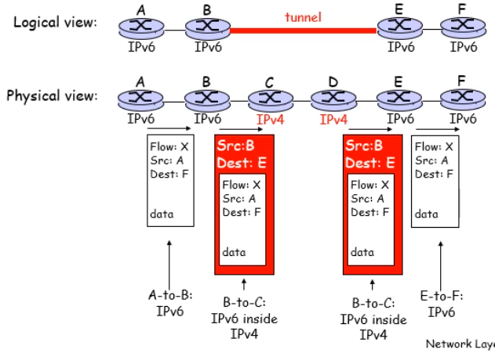
  + Increasing number of IPv6 routers but still lots of IPv4’s deployed

## Routing

* Interplay between routing, forwarding
  + 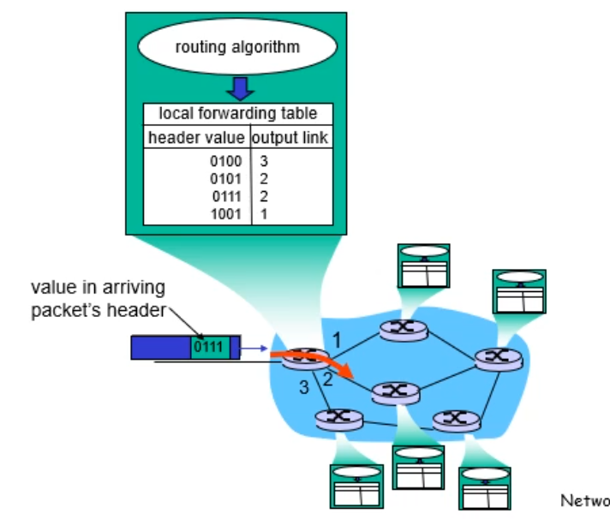
* Graph abstraction

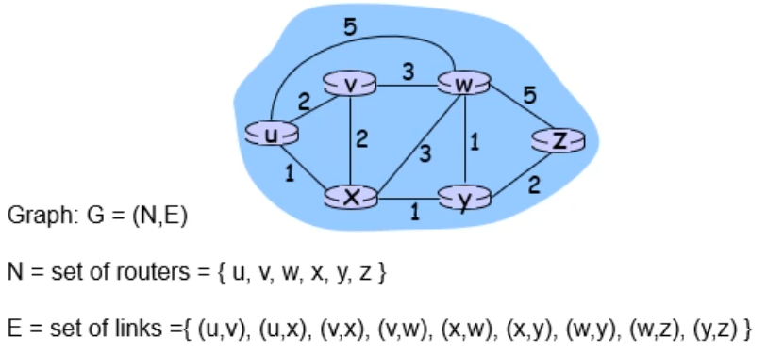

* + Costs

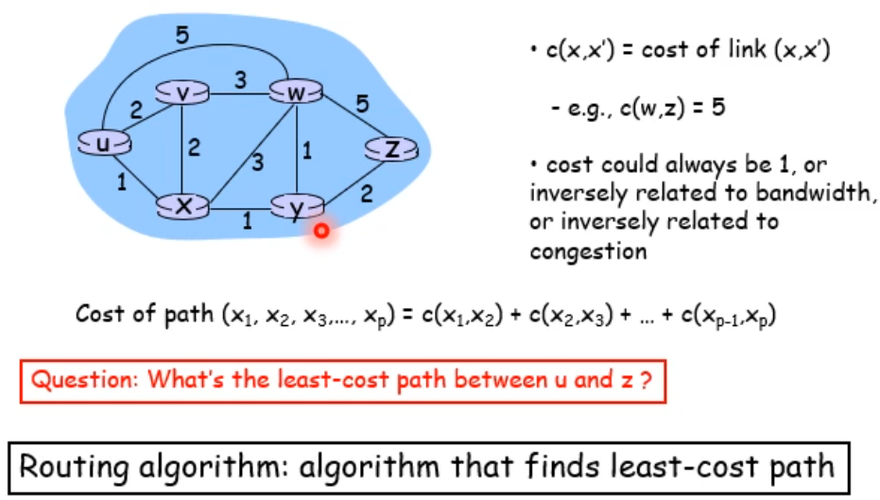

* Routing algorithm classification
  + Global or decentralised information
    - Global
      * All routers have complete topology, link cost info
      * “link state” algorithms
    - Decentralised
      * Router knows physically-connected neighbouts, link costs to neighbours
      * Iterative process of computation, exchange of info w/ neighbours
      * “distance vector” algorithms
  + Static or dynamic
    - Static
      * Routes change slowly over time
    - Dynamic
      * Routes change more quickly
        + Periodic update
        + In response to link cost changes
* Link-State Routing Algorithm
  + Dijkstra’s algorithm
    - Net topology, link costs known to all nodes
      * Accomplished via “link state broadcast”
      * All nodes have same info
    - Computes least cost paths from one node (“source”) to all other nodes
      * Gives forwarding table for that node
    - Iterative – after k iterations, know least cost path to k destinations
  + Notation
    - c(x,y) – link cost from node x to y; infinite if not direct neighbour
    - D(v) – current value of cost of path from source to destination v
    - P(v) – predecessor node along path from source to v
    - N’ set of nodes whose least cost path definitively known

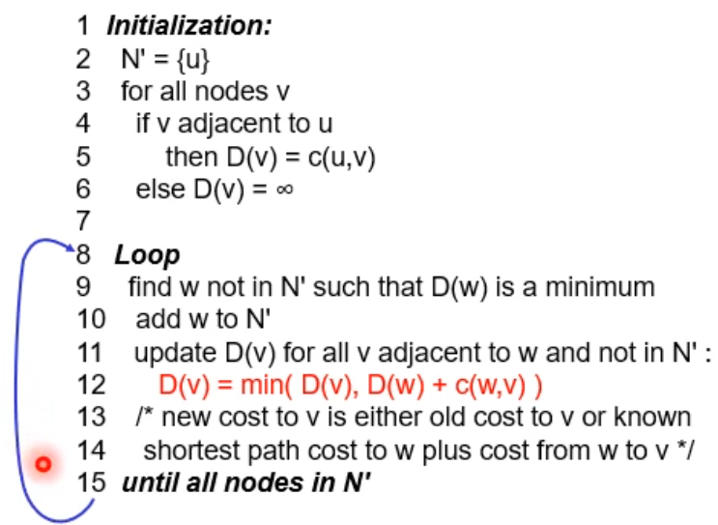

* + Example

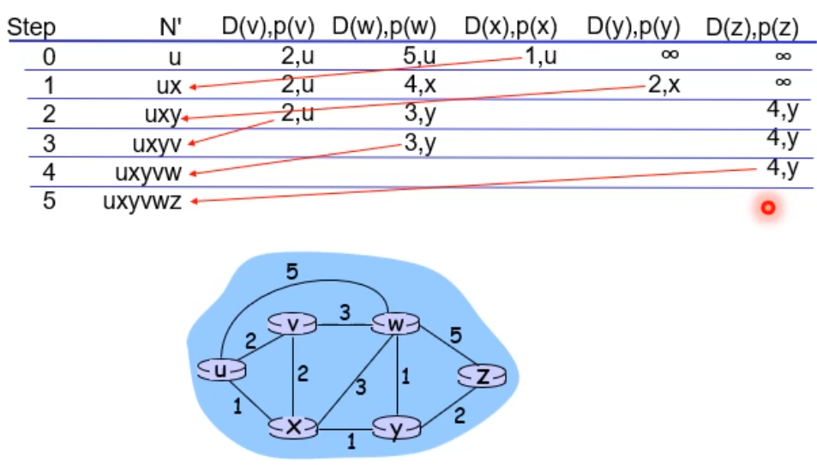

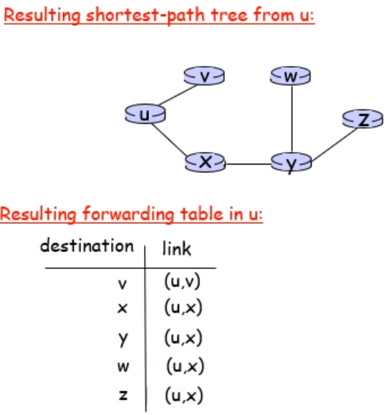

* Distance Vector Algorithm – Bellman-Ford

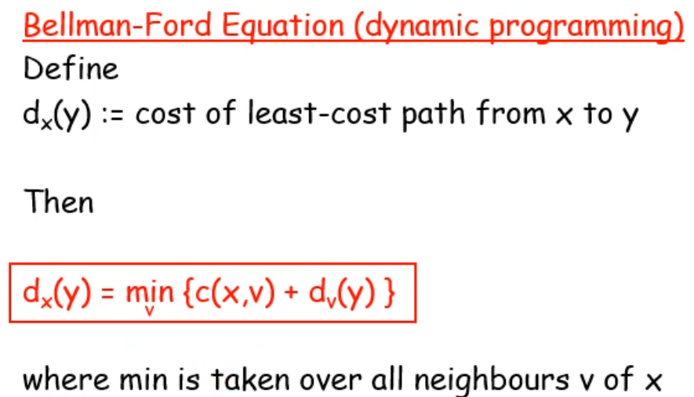

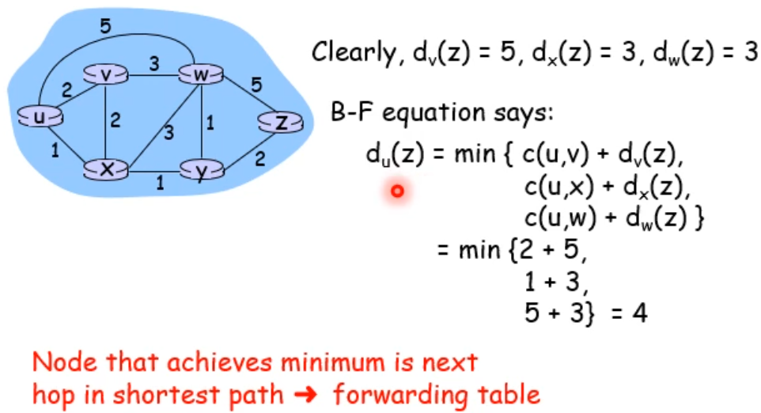

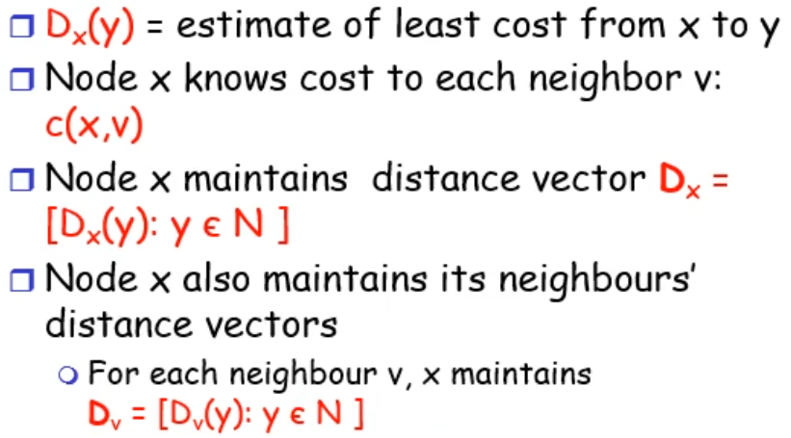

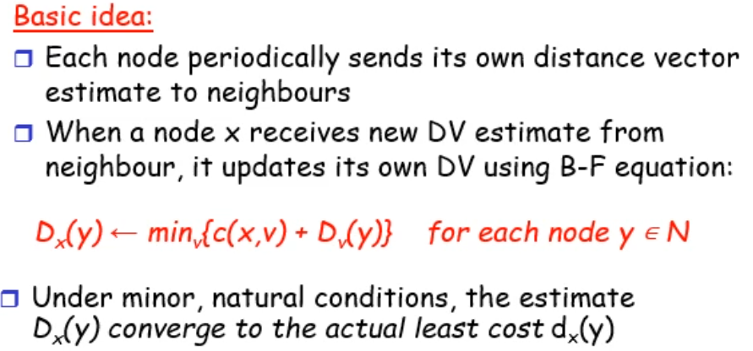

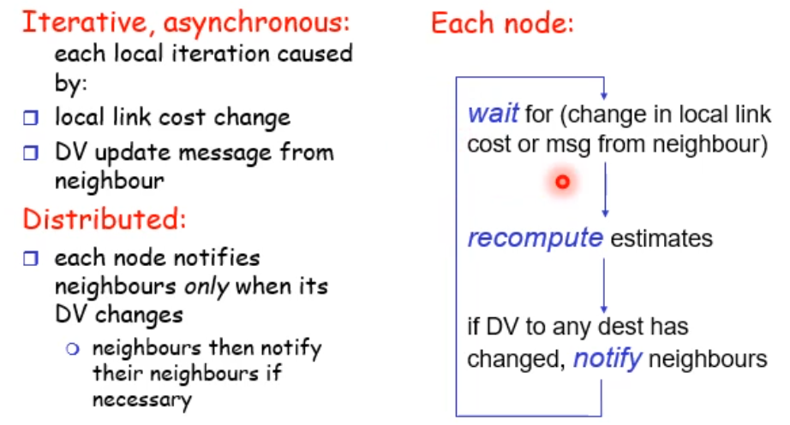

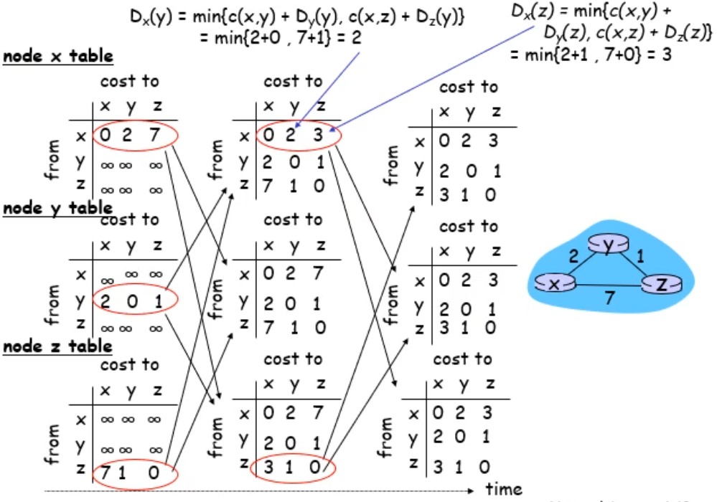

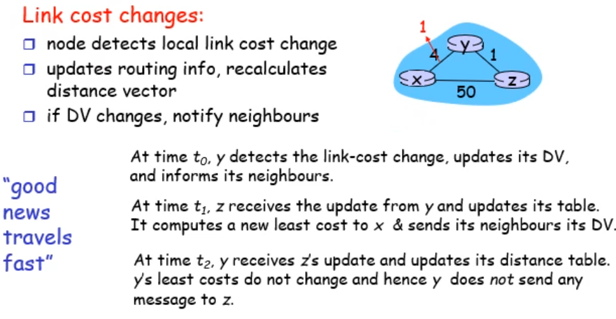

* Hierarchical Routing
  + Routing study so far
    - All routers identical
    - Network “flat”
    - Not true in practice
  + Scale: with 200 million destinations
    - Can’t store all destinations in routing tables
    - Routing table exchange would swamp links
  + Administrative autonomy
    - Internet = network of networks
    - Each network admin may want to control routing in its own network
  + Aggregate routers into regions, “autonomous systems” (AS)
  + Routers in same AS run same routing protocol
    - “intra-AS” routing protocol
    - Routers in different AS can run different intra-AS routing protocol
  + Gateway router
    - Direct link to router in another AS
  + Interconnected ASes

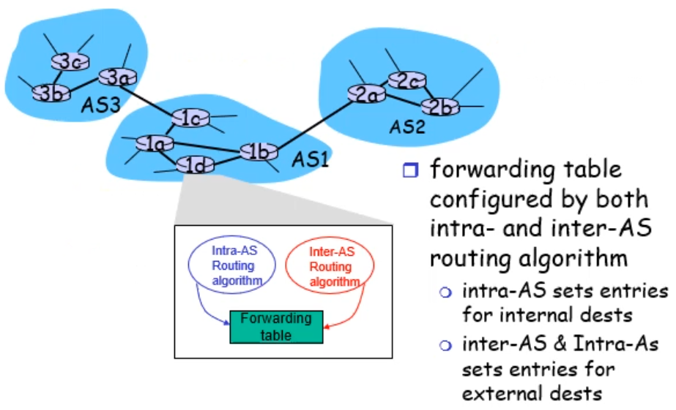

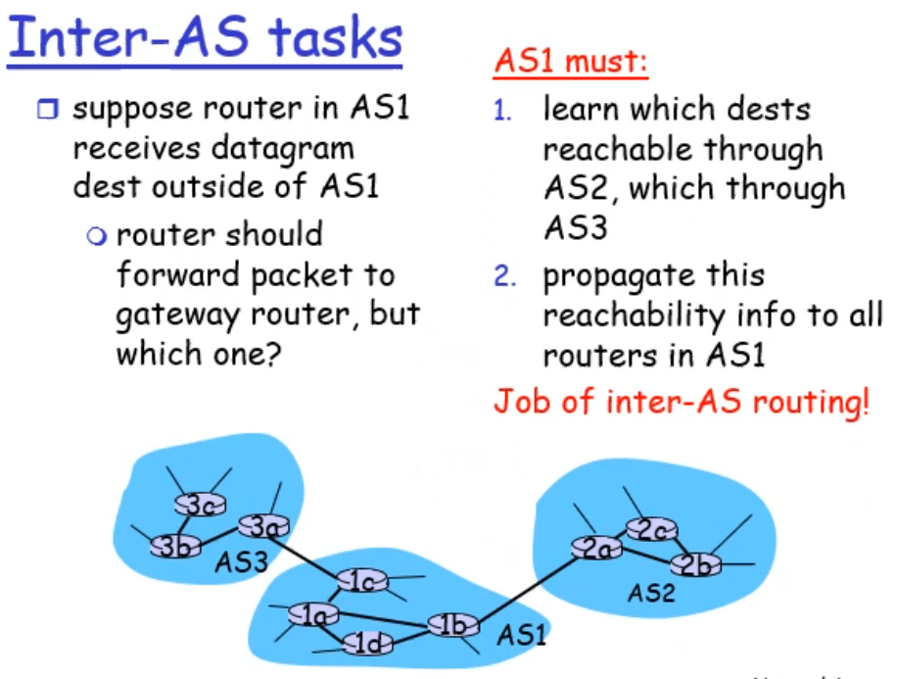

* + Examples

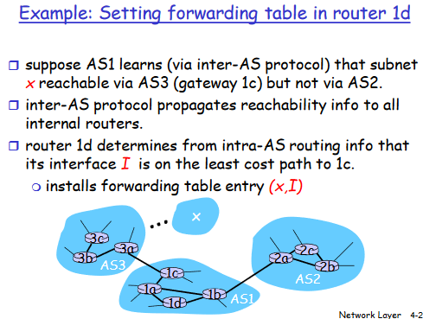

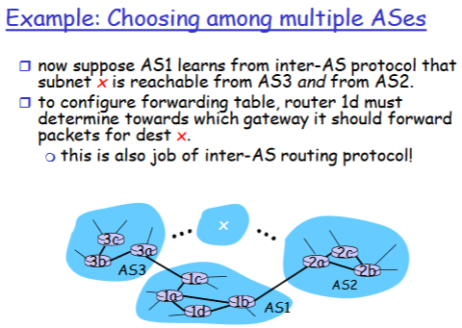

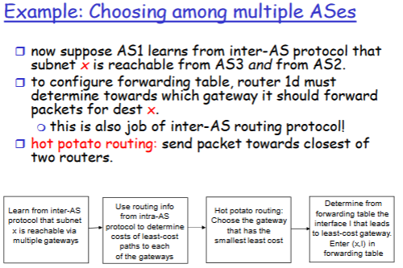

* + BGP is crucial as it glues all autonomous sytems together on the internet
    - BGP decentralised
    - Follows distance vector approach
    - Djikstra alg often used as (intra? Inter?) autonomous system routing protocol

# Local Area Networks (LAN)

## Intro/Errors

* Link layer intro
  + Hosts and routers are nodes
  + Comm channels that connect adjacent nodes along comm path are links
    - Wired links
    - Wireless links
    - LANs
  + Layer-2 packet is a frame, encapsulates datagram
  + Data-link layer has responsibility of transferring datagram from one node to adjacent node over a link
  + Datagram transferred by diff link protocols over diff links
  + Each link protocol provides diff services
    - E.g. may or may not provide rdt over link
  + Transportation analogy

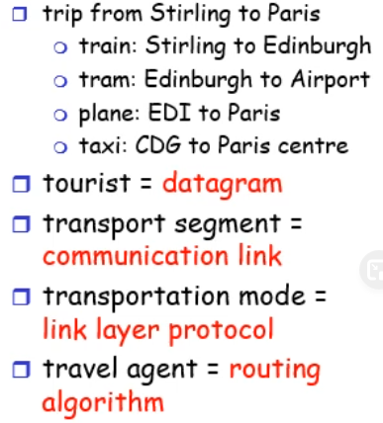

* Link layer services
  + Framing, link access
    - Encapsulate datagram into frame, adding header, trailer
    - Channel access if shared medium
    - “MAC” addresses used in frame headers to identify souce, dest
      * Diff from IP addr
  + Reliable delivery between adjacent nodes
    - Seldom used on low bit-error link (fibre, some twisted pair)
    - Wireless links: high error rates
  + Flow control
    - Pacing between adjacent sending and receiving nodes
  + Error detection
    - Errors caused by signal attenuation, noise
    - Receiver detects presence of errors
      * Signals sender for retransmission or drops frame
  + Error correction
    - Receiver identifies and corrects bit errors without resorting to retransmission
  + Half-duplex and full-duplex
    - With half duplex, nodes at both ends of link can retransmit, but not at same time
* Where is link layer implemented?
  + In each and every node
  + Link layer implemented in “adaptor” (aka network interface card NIC)
    - Ethernet card, PCMCI card, 802.11 card
    - Implements link, physical layer
  + Attaches into host’s system buses
  + Combination of hardware, software, firmware
* Adaptors communicating

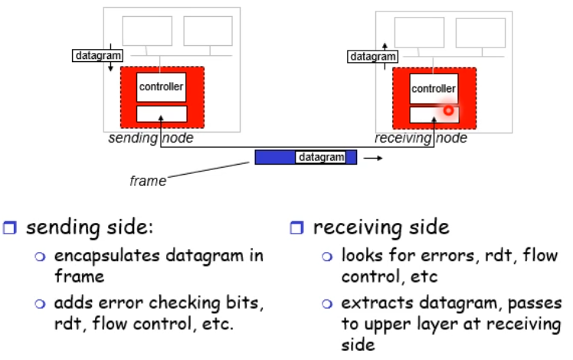

* Error detection

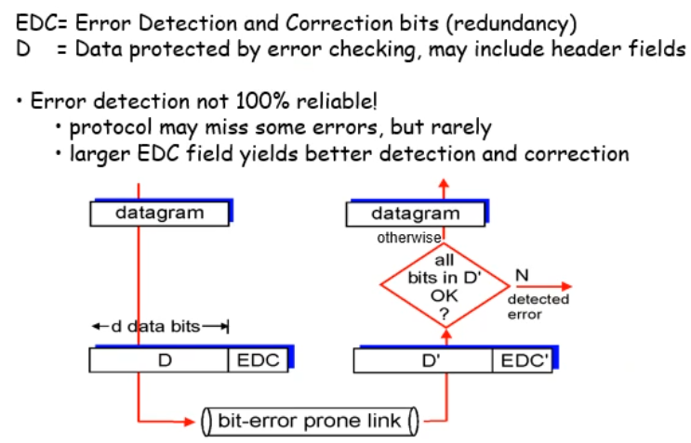

* Parity checking

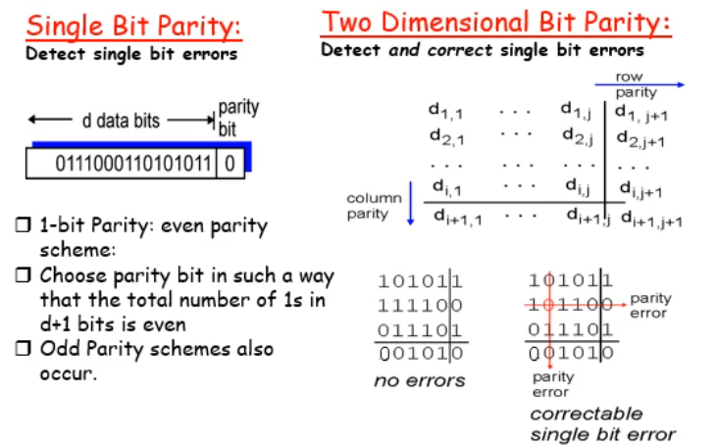

* Checksumming: Cyclic Redundancy Check
  + View data bits, D as a binary number
  + Choose r+1 bit pattern (generator), G
  + Goal: choose r CRC bits, R, such that
    - <D,R> exactly divisible by G (modulo 2)
    - Receiver knows G, divides <D,R> by G; if non-zero remainder: error detected
    - Can detect all burst errors in less than r+1 bits
  + Widely used in practice (802.11 WiFi, ATM)

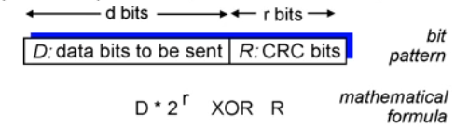

* + Based on modulo-2 calculations without carries (add) and borrows (subs) that means both are identical and basic XOR
  + Fast in hardware

## Multiple Access

* Multiple access links and protocols
  + Point-to-point
    - PPP for dial-up access
    - Point-to-point link between Ethernet switch and host
  + Broadcast (shared wire or medium)
    - Old-fashioned Ethernet
    - 802.11 wireless LAN
    - 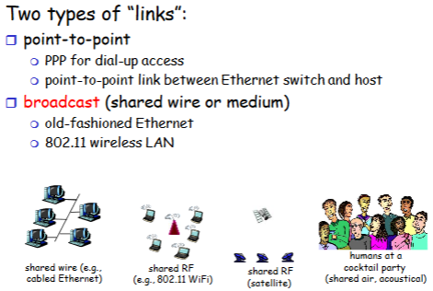
* Multiple access protocols
  + Single shared broadcast channel
  + Two or more simultaneous transmissions by nodes: interference
    - Collision if node receives two or more signals at same time
  + Multiple access protocol
  + Distributed alg that determines how nodes share channel, i.e. determine when node can transmit
  + Comm about channel sharing must use channel itself
* Ideal multiple access protocol
  + Broadcast channel of rate R bps
    - When one node wants to transmit, it can send at rate R
    - When M nodes want to transmit, each can send at average rate R/M
    - Fully decentralized
      * No special node to coord transmissions
      * No sync of clocks, slots
    - Simple
* MAC protocols taxonomy
  + Channel partitioning
    - Divide channel into smaller “pieces” (time slots, frequency, code)
    - Allocate piece to node for exclusive use
  + Random access
    - Channel not divided, allow collisions
    - “recover” from collisions
  + Taking turns
    - Nodes take turns but nodes with more to send can take longer turns
* Channel partitioning MAC protocols: TDMA
  + TDMA: time division multiple access
    - Access to channel in “rounds”
    - Each station gets fixed length slot (length = pkt trans time) in each round
    - Unused slots go idle
    - Example: 6-station LAN, 1,2,4 have pkt, slots 2,5,6 idle
    - 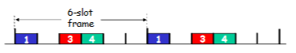
* Channel partitioning MAC protocols: FDMA
  + 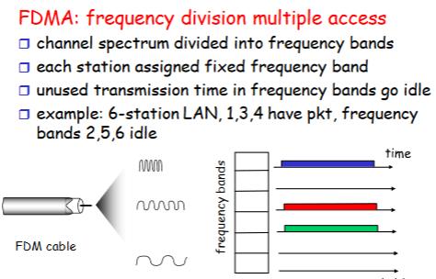
* Random access protocols
  + 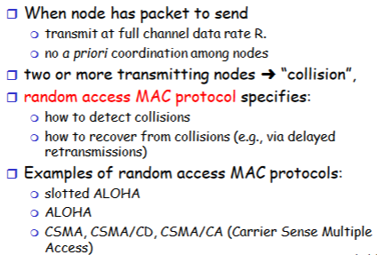
* Slotted ALOHA
  + 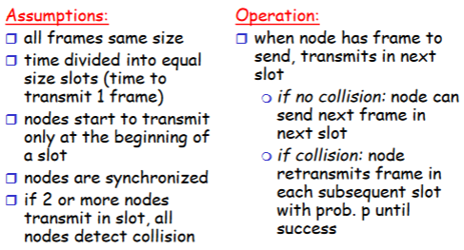
  + 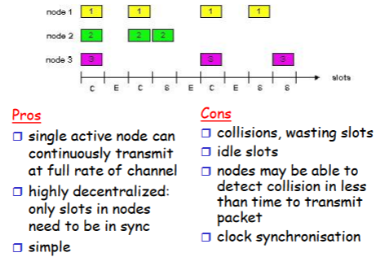
  + Slotted ALOHA efficiency
    - 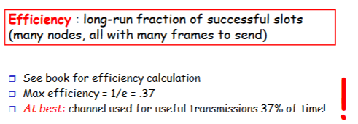
* Pure (unslotted) ALOHA
  + 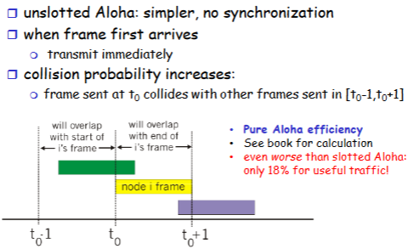
* CSMA (Carrier Sense Multiple Access)
  + 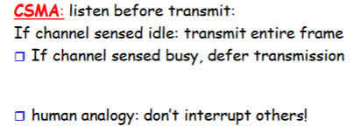
* CSMA collisions
  + 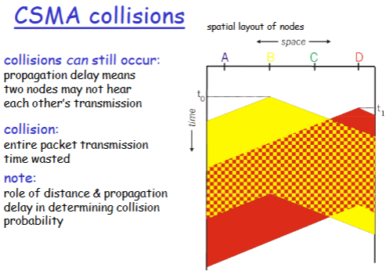
* CSMA/CD (Collision Detection)
  + 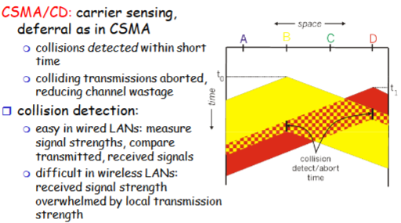
* “Taking turns” MAC protocols
  + 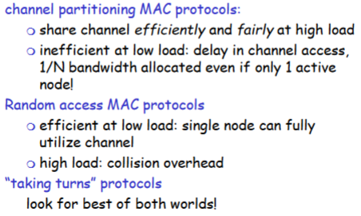
  + 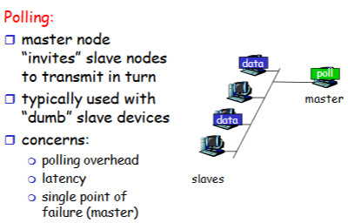
  + 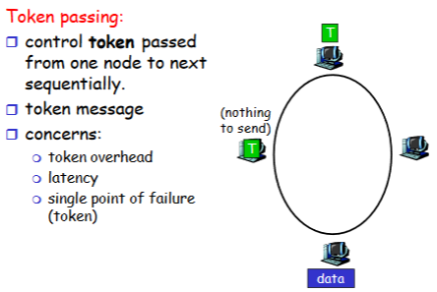
* Summary of MAC protocols
  + Channel partitioning, by time, frequency, or code
    - Time division, frequency division
  + Random access (dynamic)
    - ALOHA, S-ALOHA, CSMA, CSMA/CD
    - Carrier sensing: easy in some technologies (wire), hard in others (wireless)
    - CSMA/CD used in Ethernet
    - CSMA/CA used in 802.11
  + Taking turns
    - Polling from central site, token passing
    - Bluetooth, FDDI, IBM Token Ring

## Addressing

* MAC Addresses and ARP
  + IP address
    - Network-layer address
    - Used to get datagram from source to destination
  + MAC
    - Function: get frame from one interface to another physically connected interface (same network)
    - 48 bit MAC address (for most LANs)
* More on LAN Address
  + MAC addr alloc administered by IEEE
  + Manufacturer buys portion of MAC address space (to assure uniqueness)
  + Analogy
    - MAC addr: like national insurance number
    - IP address: like postal address
  + MAC flat address 🡪 portability
    - Can move LAN card from one LAN to another
  + IP hierarchical address NOT portable
* 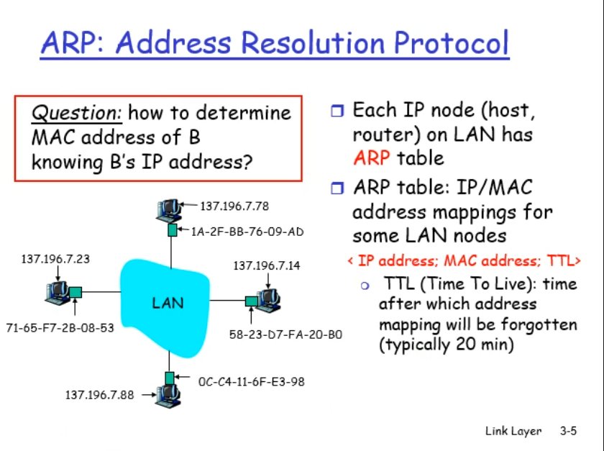
* 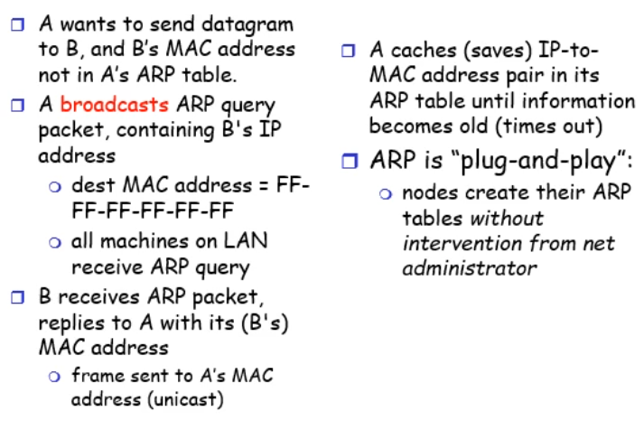
* Addressing: routing to another LAN

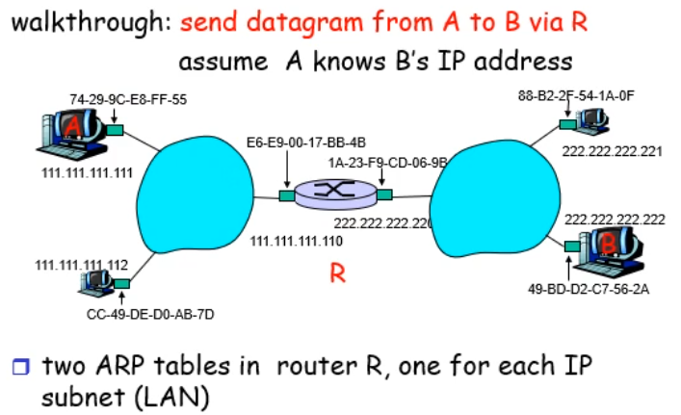

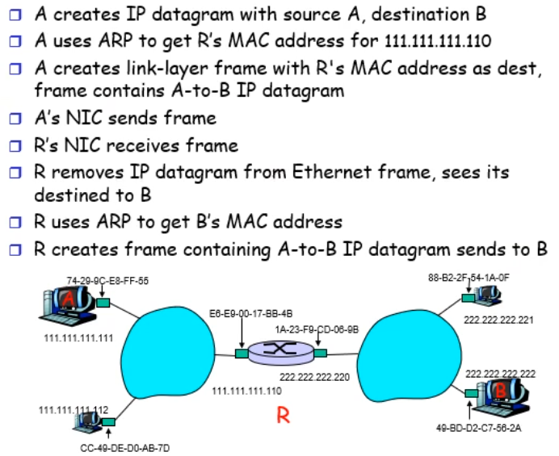

## Ethernet

* Ethernet
  + Cheap for NIC
  + First widely used LAN technology
  + Simpler and cheaper than token LANs and ATM
  + Kept up with speed race
* Star topology
  + Bus topology popular through 90s
  + Roday star topology
    - Active switch in centre
    - Each “spoke” runs a separate Ethernet protocol (nodes do not collide with each other)
* Ethernet frame structure
  + Sending adapter encapsulates IP datagram (or other network layer protocol packet) in Ethernet frame
  + Preamble
    - 7 bytes with pattern 10101010 followed by one byte with pattern 10101011
    - Used to sync receiver and sender clock rates
    - 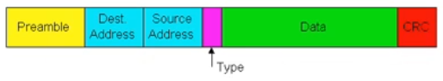
  + Addresses: 6 bytes
    - If adapter gets frame with matching dest addr, or with broadcast addr (eg ARP packet), it passes data in frame to network layer protocol
    - Otherwise adapter discards frame
  + Type: indicates higher layer protocol (mostly IP but others possible, e.g. Novell IPX, AppleTalk)
  + CRC: checked at receiver, if error detected, frame dropped
  + Connectionless: no handshaking between sending and rrecieving NICs
  + Unreliable: receiving NIC doesn’t send acks or nacks to sending NIC
    - Stream of datagrams passed to network layer can have gaps
    - Gaps filled if app is using TCP
    - Otherwise, app will see gaps
  + Ethernet’s MAC protocol: unslotted CSMA/CD
* 802.3 Ethernet standards: link and physical layers
  + Many diff ethernet standards
    - Common MAC protocol and frame format
    - Diff speeds: 2 Mbps, 10 Mbps, 100 Mbps, 1Gbps, 10Gbps
    - Different physical layer media: fibre, cable
  + 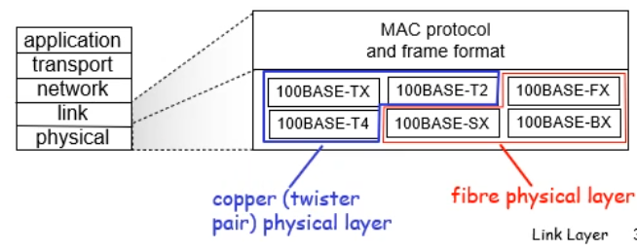

## Switches

* Hubs
  + Bits coming in one link go out all other links at same rate
  + All nodes connected to hub can collide with one another
  + No frame buffering
  + No CSMA/CD at hub: host NICs detect collisions
* Switch
  + Link-layer device: smarter than hubs, take active role
    - Store, forward Ethernet frames
    - Examine incoming frame’s MAC address, selectively forward frame to one-or-more outgoing links when frame is to be forwarded on segment, uses CSMA/CD to access segment
  + Transparent
    - Hosts are unaware of presence of switches
  + Plug-and-play, self-learning
    - Switches do not need to be configured
  + Allows multiple simultaneous transmissions
    - Hosts have dedicated direct connection to switch
    - Switches buffer packets
    - Ethernet protocol used on each incoming link, but no collisions; full duplex
      * Each link is its own collision domain
    - Switching: A-to-A’ and B-toB’ simultaneously, without collisions
      * Not possible with dumb hub
      * 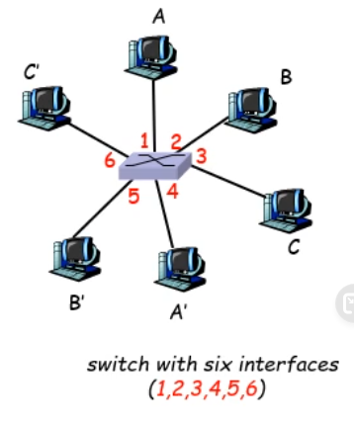
* Switch table
  + 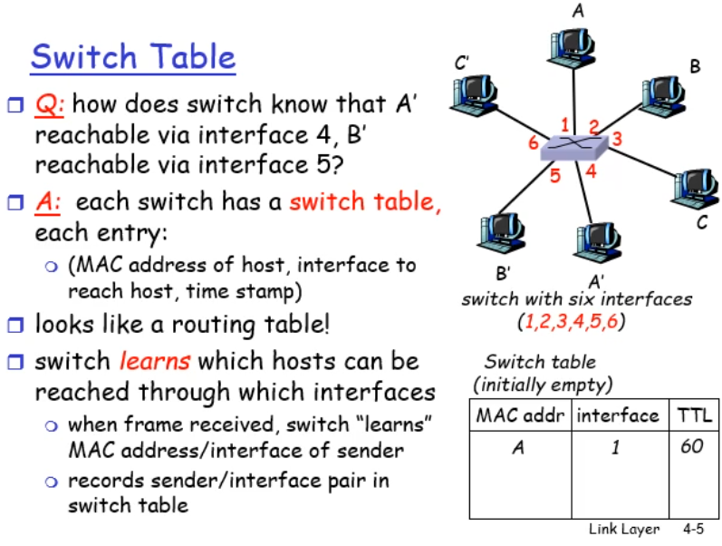
* Interconnecting switches
  + Switches can be connected together
  + 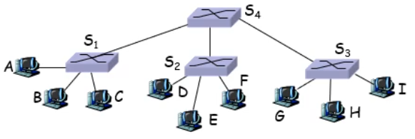
* Switches (bridges) vs routers
  + Both store-and-forward devices
    - Routers: network layer devices (examine network layer headers)
    - Switches are link layer devices
  + Routers maintain routing tables, implement routing algorithms
  + Switches maintain switch tables, implement filtering, learning algorithms

# Wireless Communication

## Wireless Networks

* Wireless
  + 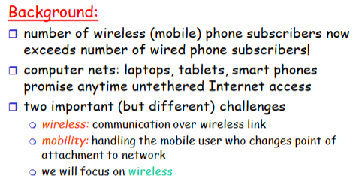
* Elements of a wireless network
  + 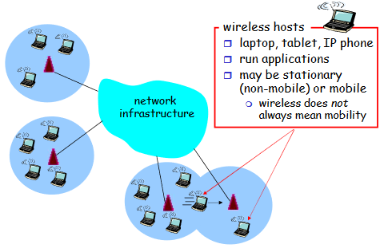
  + 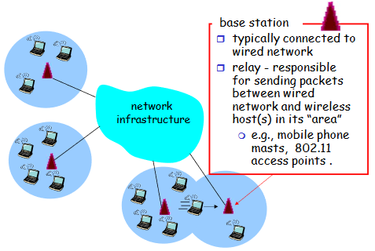
  + 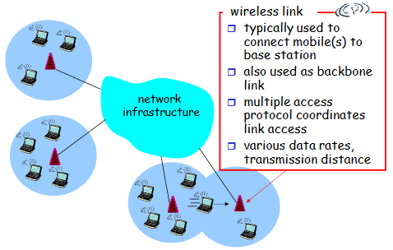
  + 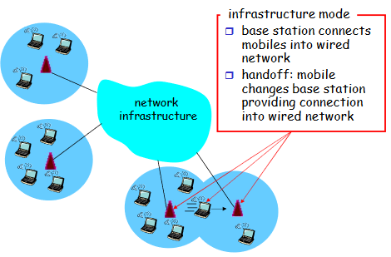
  + 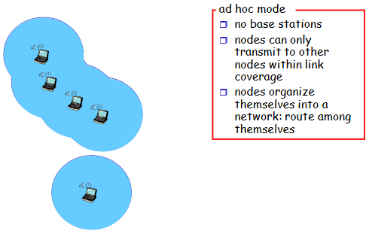
* Wireless network taxonomy
  + 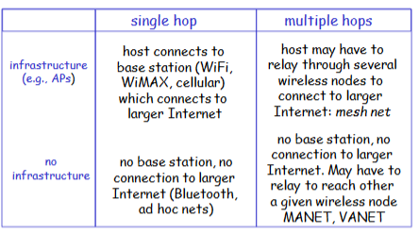
* Wireless link characteristics
  + 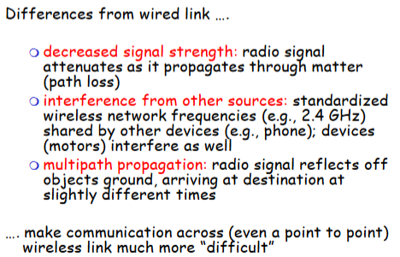
  + 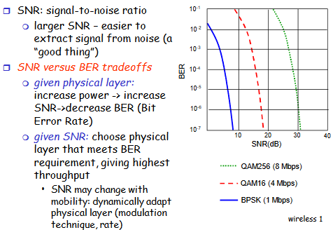
* Wireless network characteristics
  + 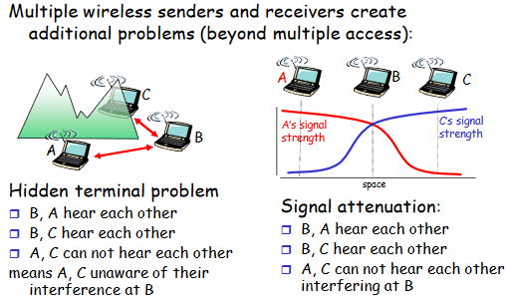
* Code division multiple access
  + 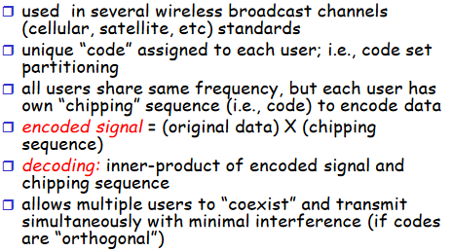
* IEEE 802.11 wireless LAN
  + 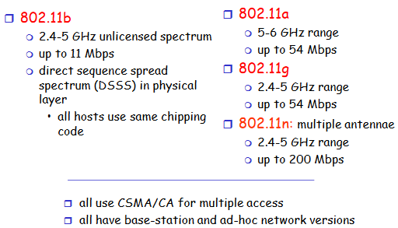
* 802.11 LAN architecture
  + 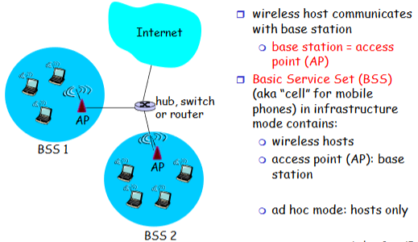
* 802.11 channels, association
  + 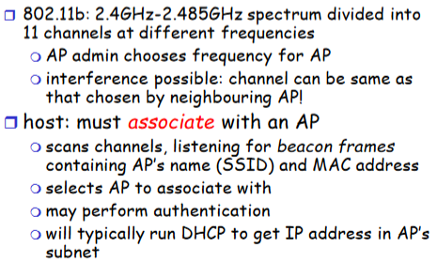
* IEEE 802.11: multiple access
  + 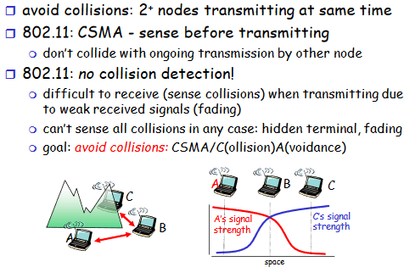
* IEEE 802.11 MAC protocol: CSMA/CA
  + 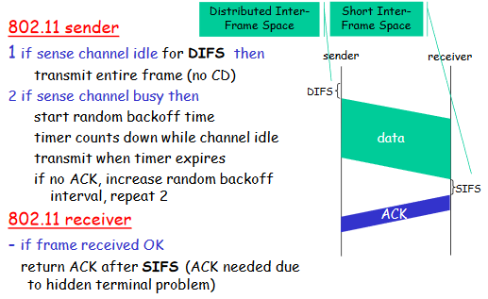
* Avoiding collisions
  + 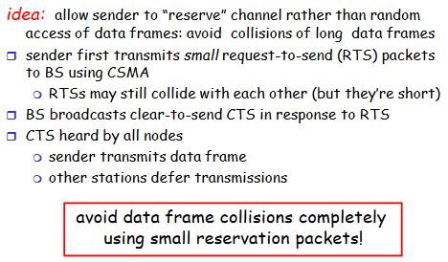
* Collisions avoidance: RTS-CTS exchange
  + 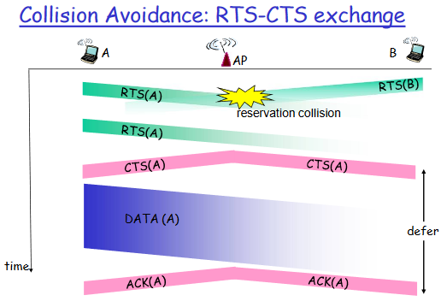
* 802.11 frame: addressing
  + 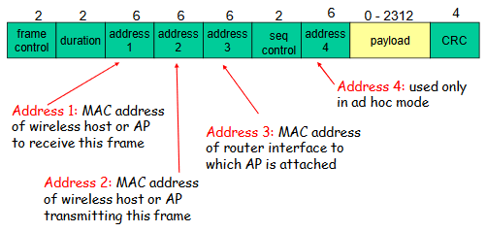
  + 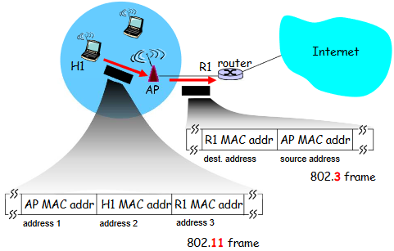
* 802.11 frame: more
  + 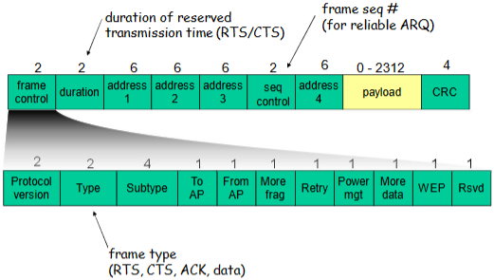

# ***IP Security***

## Principles

* Encryption and the protocol stack
  + Consider layers of network protocol stack
    - Encryption at the app level secures a particular app
    - Encryption at transport layer secures all apps using the given transport protocol
    - Encryption at network layer secures all comms for protocols using the network layer
    - Encryption at the link layer secures all network layer comms and above
  + Above approaches secure comms but they do not always authenticate it
  + Significant overhead in encrypting everything – want to be able to turn on and off
* Solution to network authentication
  + Use a nonce + shared password
  + Sally sends message to Rob saying “I’m Sally”
  + Rob sends Sally a ‘nonce’ (a one time use random unique code)
  + Sally hashes nonce + shared password
    - Sends encrypted value to Rob
  + Replay by Eve will now work since new nonce used each time
  + 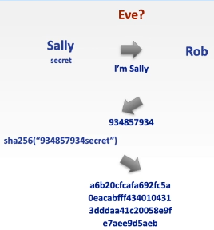

## Email/PGP

* Securing email
  + Requirements
    - Confidentiality
    - Sender authentication
    - Receiver authentication
      * Message only readable by intended recipient
  + Confidentiality
    - Could use private shared key
      * Issues – sharing key
    - Could use public key cryptography
      * Issues – speed, not ideal for sending large messages
    - Solution
      * Generate symmetric encryption session key used for a single email exchange
      * Send the session key using public key cryptography
      * Encrypt message with shared session key plus hash and send
  + Confidentiality + authentication
    - Add authentication process to confirm Sally as the sender and ensure message is not modified in transit and cannot be read
      * Create an email message **m**
      * Calculate a hash of this message **h = hash(m)**
      * Sign/encrypt this hash with the sender’s private key **s = encrypt(h, Spriv)**
    - Now sender sends the message as discussed before
      * Create random session key r for use in the symmetric encryption process
      * Use senders private key to encrypt r: **rS_priv = encrypt(r, Spriv)**
      * Use receiver’s public key to encrypt rS_priv: **rSR = encrypt(rS_priv, Rpub)**
      * Create encrypted composite message of message mand encrypted hash s
        + emh = symmetric(m + s, r)
      * Email the symmetrically encrypted message emh and the asymmetrically encrypted session key rSR that will open it
    - Receiver must now unwrap this process
      * 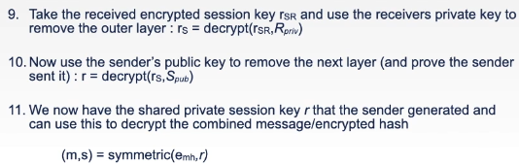
    - Checking the message has not been altered
      * 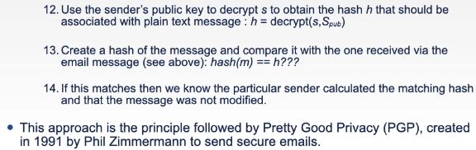

## SSL

* Securing the Transport Layer using SSL/TLS
  + Secure Socket Layer (SSL)/Transport Layer Security(TLS) is used to encrypt all app traffic that uses the TCP protocol and supports SSL
    - We start with the standard TCP exchange – the sender sends a SYN packer, the receiver replies with a SYNACK and the sender then sends back an ACK packet
    - Having established a connection, the sender now sends an SSL Hello message
    - The receiver replies with a list of supported symmetric encryption algorithms and a receiver nonce
* SSL – encryption algorithms and certificate
  + The sender selects a symmetric algorithm and responds with
    - The chosen symmetric algorithm
    - A message authentication code (MAC) alg (a form of hash function)
    - A sender certificate
    - A sender nonce
* Verification and pre master secret
  + Receiver unpacks and uses the sender’s info as follows:
    - Verifies the sender’s certificate via a CA
    - Extracts sender’s public key Spub from the validated certificate
    - Generates a Pre-Master Secret (PMS)
    - Encrypts the PMS with Spub : PMSSpub
    - Senders PMSSpub to sender
* Generate session keys from PMS
  + Sender and receiver now use the PMS to create the Master Secret which they partition into 4 keys
    - ES – session encryption key for sender
    - MS – session MAC key for sender
    - ER – session encryption key for receiver
    - MR – session MAC key for receiver
  + Client sends a MAC (hash) of the set of all prior handshake messages
* Sending encrypted data
  + Now in position to transfer data
    - Since we wish to use MACs to confirm messages are not being tampered with and don’t want to wait until complete message sent before calculating a MAC, send the block of data as a record
    - 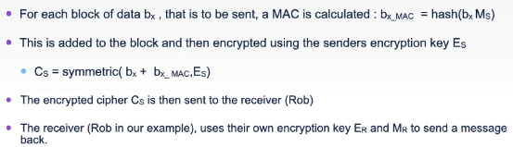
* Record format
  + SSL record structure
    - 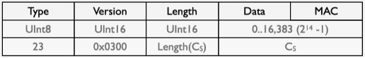
  + Record types:
    - Handshake (22, 0x16), Change Cipher (20, 0x14), Alert (21, 0x15), Application Data (23, 0x17)
* Decoding the data
  + Given that the sender and receiver both have all 4 keys, they are able to decode each others messages
    - 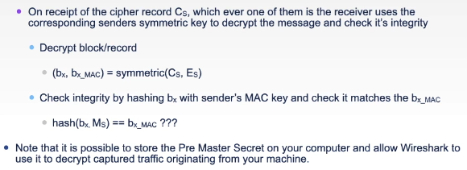
* Closing the connection
  + Need to consider how to properly close the connection
    - Can’t rely on sender sending a FIN message to receiver to terminate a session
    - Receiver looks out for a MAC signed SSL termination field
    - Only the original sender can provide this
    - Relying on a FIN packet is not safe

## VPN

* Securing the network layer – IPsec & VPNs
  + Will now drop down to underlying network layer and consider how this can be secured
    - At this level we wish to hide and encrypt the comm between two end points, including even the protocol, original source and destination IP addresses for the traffic while it is enroute
    - Achieved by wrapping a normal IP packet within an IPsec packet where the original inner packet is encrypted. The IPsec packet is then routed according to its destination address as a normal packet
  + IPsec principles
    - Original packet type, protocol, source, and destination are hidden (TCP, UDP etc)
    - Only IPsec source and destination are known
    - The source and destination addresses act as the entry and exit points for the transmission and these two nodes are responsible for encrypting and decrypting the original packet
    - A client connects to the entry point and routes data to it, the entry point encrypts the data and sends it on its way across the internet as normal
    - The destination node recognises the arrival of the IPsec packet and has the relevant keys to decrypt it and check authenticity (in a similar manner to the principles shown for SSL)
  + Encapsulated security payload (ESP) structure
    - 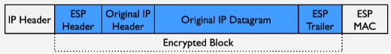
    - ESP packet conforms to a standard IPv4 packet and will be routed accordingly
    - This approach enables a Virtual Private Network to be built
      * When a user connects to it, they are sending and listening to traffic on a particular node
      * The node plays the role of both entry and exit point and requires a dual set up process, one for each direction of traffic; each relationship is known as a Security Association (SA)
      * A user can specify an exit node so that their traffic appears to come from the exit node (and is perhaps in a different country to them)
      * Note that the exit node can see the original datagram contents as it emerges from the virtual tunnel. Further security needed to prevent data from being readable (e.g. SSL). Need to trust your VPN…

# ***Forensics***

## Prep

* Computer forensics
  + Process of analysing digital media to determine if illegal or undesirable activity has taken place
    - Forms part of meeting the requirement of accountability where users actions can be checked, we can look for intrusion into system and determine what actions should be taken to provide future availability
    - From a legal perspective; concerned w/ collection of digital evidence that is suitable for presentation in court of law
    - May be used within business as support for termination of contract; must therefore be sufficient to meet legal validation
* Incident Response Process
  + Prep
    - Prepare incident response team and systems to anticipate security breach
  + Detection
  + Initial response
    - Record circumstances of intrusion
    - Assemble IRT and notify relevant parties
  + Data collection
    - Static/volatile data
    - Monitor for further intrusions
  + Analysis
    - If incomplete picture from data, analysis will be hard
  + Report
* Preparation - checksum
  + Record cryptographic hashes of critical files on a known good system
    - Ideally this machine will be a clean install and will not have been networked prior to hash calculation
    - Updates may have to be downloaded and copied to benchmark machine; need to calculate new hashes after update and check against update list to ensure that only updated files have changed
    - Note that hashsum table and application should not be stored on vulnerable/networked systems
      * Hacker may subvert SHA program/table
* Prep – Logging
  + Configure secure logging
    - Unix – syslog config
    - Windows – by default usually off
  + Use a remote logging server
  + Enable full network device logs
  + Log everything – storage not usually an issue
* Prep – defences
  + Ensure all known updates and patches have been applied
  + Disable all unused services
  + Check required services are not in default config
  + Ensure backups are made of all systems where failure/loss of data or integrity will cause harm and that backups are not stored on site
* Prep – networks
  + Use firewalls and create relevant DMZs
  + Access control lists for routers
  + Maintain accurate map of network topology
  + Encrypt network traffic where viable to prevent eavesdropping
  + Require network authentication
* Prep – policy
  + Known security policy needs to be in place before you act on a security incident
    - If employees have prior expectations of privacy due to a lack of company policy, they may not respond well to subsequent actions

## Data

* Response toolkits – software
  + Multi-OS bootable machine
    - Linux, Windows
  + Forensics software packages
    - See module resources for links
  + Clean, bootable USB disks/DVDs
  + Flexible file viewing software
    - Must allow for ASCII and byte code view
  + Disk write blocking software
  + Secure disk image of complete toolkit
* Collecting data
  + Volatile memory state (RAM)
  + System data and time
  + Current users
  + Current processes
  + Open sockets
  + Applications listening on sockets
  + Complete list of external systems that have a current or recent connection to system
  + Date and time stamps for all files
  + Copy of registry, .ini or config files
* Collecting data – Windows
  + Record current state
    - Log files
    - Memory - volatility
  + Command prompt
    - netstat
    - nbtstat
    - arp
    - ipconfig
    - doskey
  + SysInternals
  + Foundstone forensic tools
  + SHA/MD5 checksum utility
  + Netcat/cryptcat
* Collecting data – Unix
  + Record current state of all log files & memory – volatility
  + Unix command line utilities
    - Find
    - Netstat
    - Dig
    - Ps
    - Strings
    - …
* Collecting network data
  + Monitoring, intercepting and recording network traffic
    - Wireshark, tcpdump – packet capture
  + Event monitoring
    - Watch for certain events occurring, then capture data
  + Trap & trace monitoring
    - Record types of interaction, not data

## Analysis

* Data analysis
  + Copy recorded forensic materials onto analysis machine
  + Examine processes that were running and comm channels
  + For suspect processes:
    - Examine process ownership and started sub processes
    - Cross check that processes should be communicating on given ports and to particular IP addresses
    - Scan their memory and executables for suspicious strings
    - Submit executables/DLLs to anti-virus software/sites (e.g. VirusTotal) for analysis
    - Examine byte code via hex editor(???)
* Locations – Windows
  + Check
    - Volatile data
    - Free disk space
    - Logical file system
    - Logs
      * Events
      * Registry
      * Applications
    - Swap files – recently memory resident
    - Application cache files
    - Temp files
    - Recycle bin
    - Printer spool
    - Email logs + .pst for Outlook
* Locations – Unix & Linux
  + Check logs
    - /var/log – very useful logs, including
      * syslog
    - application logs
    - Shell history
  + File time stamps
    - Check created/accessed/modified time stamps for previous week/month
    - Pattern of file accesses may emerge
  + Config files - /etc
  + Unusual file names
* tcpdump -> tcptrace
* tcptrace session information
* Analysis – Summary
  + Check
    - Logs
    - Trust relationships
  + Identify
    - Recently modified files
    - Unauthorised or recent user accounts/group changes
    - Unexpected processes/services
    - Hidden or unexpected files/directories
    - Unauthorised access points
    - Suspicious network traffic
* Summary – forensics
  + Introduction
    - What is Computer Forensics?
    - The Incident Response Process
  + Data collection
    - Response Toolkits
    - Recording Information
  + Data analysis
    - Windows
    - Unix
    - Networking

# ***Authentication & Authorisation***

## Passwords

* Authentication
  + Operates on principle of something the user
    - Knows
    - Has
    - Is
  + Strong authentication uses two or more of above methods
    - More forms used, more inconvenient for user, more likely to be careless
* Passwords & PINs
  + Personal Identification Numbers
  + Weaknesses
    - Overuse
    - Frequently lost or forgotten
  + Passwords frequently secured via one way encryption (hash) of the password, stored in a password file
  + How many authentication attempts? 3? 4? Unlimited?
  + Password expiry leads to password reuse
  + Password length – 32 ASCII character password approximates to 128 bit key
* Attacks
  + Frequent methods used to break passwords are to try
    - Brute force
    - Common passwords
    - Passwords associated with a user
    - Asking the user
* Password usage
  + Use 8 characters or more (~209 billion permutations)
  + Use non-alphabetic characters
    - Numbers uncrease permutations to 36c
    - Punctuation and numbers also guard against dictionary attacks
* One time passwords
  + Useful is use an auto-generator
    - Login as normal with username and password
      * Preliminary authentication
    - System challenges user with a one time key based on identity and time
      * Key entered into one-time password device
      * Device generates corresponding response key
    - User enters response key and if correct, allowed to continue
  + Common use in banks

## Biometrics

* Bionmetrics
  + Focused on something you are
    - Iris, face, fingerprint
  + Issues
    - Can sometimes be intrusive and costly although becoming more common (e.g. Apple Touch ID)
    - Uses certainty thresholds – what is an acceptable limit
      * Frequently the authentication data exhibits noise (Car parking)
    - How is the limit decided? A balance must be struck to reduce
      * False positives – system does not recognise your iris, fingerprint, etc
      * False negatives – system recognises someone else’s fingerprint as your own
    - Should they be the equivalent of a username?
    - Single point of failure
      * If biometric system fails to recognise your iris, what are your options
    - Biometric systems are only as secure as the link between scanner and system
      * If an attacker can get in the middle, they can authenticate whoever they like
    - What if biometric measure forged or stolen?

## Background

* Many levels where access control may be required
  + Memory
  + Files
  + Directories
  + Programs
  + Devices
  + Authentication system
* Access rights – approaches
  + What approaches cn we take to securing a system
    - None
      * Permissible in limited cases
    - Isolation
      * All users and processes strictly separate
    - Share all or nothing
      * Objects declared to be public or private
    - Access control list
      * Objects note which user/group can use it
    - Usage control lists
      * Objects note who can use it and what operations they may use (e.g. read, write but not execute)
* Access rights- history
  + Early OS had little or no access control
  + Single user accounts were introduced
    - If you could switch on and login, you were ‘root’
  + Multiple accounts on the same computer were the next step
    - A user’s program could ‘peek inside’ system memory and access whatever it saw
    - If process accidentally used up all the memory, could crash everything
  + Virtual memory per user introduced
    - Account & processes operated in their own virtual ‘sandpit’
    - Systems much more reliable
  + Hierarchical access rights with domains, groups, users introduced
  + System level access off by default
    - If system needs to change a setting which may reconfigure it, the user is prompted to confirm that this action is intended and acceptable
      * If malicious program attempts to gain rights, user alerted

## File Access Rights

* File access rights
  + Access Rights for files provide a good example of access control mechanisms
    - All/none – Original IBM-OS
      * Assumed trust of user
      * Coarse division of user in standard and administrator
      * Based on batch processing model which matched early computer use
    - Group protection – access to a file or folder is determined by group rights
      * UNIX has 3 groups: user, group, world
        + User is the account holder, group is a defined group the user is in e.g. staff, world is everyone not in your group
        + Access capability is divided into read, write, and execute permissions (rwx)
        + 9 bits control access to a file specified in the order user/group/world (e.g. rw-r—r--)
      * Access permissions for a folder
        + Rwxr-xr-x or 755 (111 101 101)
        + User has read/write/execute, group has read/execute, world has read/execute
        + Execute is acceptable for a directory since you cannot run it but may wish to run something in it
        + Permissions are hierarchical, if a higher level folder says you cannot execute then it overrides the current permissions, hence folders need to be more flexible in their permissions
        + …
  + File Access Rights – Windows
    - Group protection – Windows
      * Access to a file or folder is normally determined by group rights
        + The OS starts with Administrators, Power Users, Users, Guests but more can be added
  + Access rights – Databases
    - Commercial databases require consideration of:
      * Authentication
        + Users should need to login to access data
      * Access Control
        + Once logged in, they should have controlled access to relevant tables and fields
        + Access control will also specify read/write/create/delete permissions
      * Audit
        + User actions should be logged to determine where changes originated
        + Audit process should allow for ‘roll-back’ of database to previous state
      * Availability
        + Users should have access to relevant data
    - Access should be restricted on need to know basis
    - Sometimes necessary to restrict access on a field by field basis
      * E.g. Payroll data including names, addresses
    - If access controls are not used, it increases the likelihood that an untrusted or temporary employee could walk off with sensitive data
* Kerberos Protocol
  + Kerberos is a standards-based network auth protocol for client/server applications developed by MIT
    - Used in Windows, Linux, Apple OS X
    - Kerberos initially used symmetric encryption (Secret keys) but now uses public key encryption together with an Auth Server and a Ticket Grading Server
    - The two elements combine to provide a Key Distribution Center (KDC)
  + Provides a single sign on environment enabling user to log in once and then access any allowable data that is secured with the same Kerberos service

# ***Rogue Software***

# ***Securing Software***

## Passwords

* Managing passwords
  + Ideally one way encryption should be used
    - System stores hashed password in database
    - When a user enters a password, the hashed version of this password is compared against the stored hashed version of the password
    - Creating nonsense words or substituting numbers or symbols can help since less likely to be in common lookup tables – still not ideal because of search engines and hash websites
* Salting passwords
  + Hash password in combination with some random but unique value associated with each user
  + Don’t use same salt for each user
  + Best solution is to add a consistent but different salt to each stored password and store the encrypted salt along with the salted, hashed password
    - For each user, randomly generate long salt value
    - Concatenate the user’s password with the above salt value and calculate the hash value of this result
    - store salted hash value as a record of the users encrypted password
    - Using a symm encryption method, encrypt the random unique salt value with a local key and store this in the user’s record as well
      * Store in a file outside web accessible directories
* Validating the passwords
  + To validate a user’s password
    - Read local encryption key and use it to decrypt the encrypted salt that is stored with a user’s record
    - Concatenate the unencrypted salt with the password they have supplied
    - Hash this concatenated value
    - Compare it with the stored hashed value to validate the user
  + If hacker steals database, they will not be able to work out what the salt values are for each user; even if they could, they would have to make lookup tables for every single user and search through

## BufferOverflow

* Common code flaws
  + Validation
    - Improper validation/permission checks
  + Domain
    - Data access controls – a user in an unauthorised domain accesses information they should not be party to
  + Serialisation
    - Program control flow
  + Identification/Authentication
    - Invalid/weak ID checks
  + Boundary conditions
    - Value limits (and 0)
    - Data allocation
  + Logic errors
* Buffer Overflow
  + Buffer overflow failures in code are responsible for the majority of current software based security breaches
    - A buffer overflow occurs when more data is entered into memory than was expected
    - The extra data overflows out of the assigned memory area and into the subsequent memory locations
    - In principle, rigorous languages such as Java and C# do not normally suffer from buffer overflow since compiler and VM check for such events and prevent them
  + Some coders attempt to avoid checking all entered string lengths by just having very large amounts of mem. alloc. to character arrays (or arrays in general)
    - Slows down code since array must be moved around in memory
    - Hackers will still push limits to find out just how long array is

## Incompatible Data

* Incompatible Data
  + Errors can occur when data of incorrect type is asupplied and cast to a different type
  + Depending upon language, different outcomes will occur
  + Hacker may attempt to crash a program (or inject code) by relying on the way in which a specific language deals with type casting problems
* Invalid units
  + Hacker could provide data out with the expected range of values to determine if can make program crash

## BufferOverRead

* Heartbleed
  + Exploited a vulnerability in the OpenSSL implementation of the transport layer security negotiation of a secure connection
    - Setting up a secure socket connection can take a little time
    - In order to check server is still connected, client device continually sends heartbeat packets to server containing a short message
    - Heartbeat message structure:
      * Message
      * 16 bit integer indicating length of message
      * On receipt of message, server just creates a new packet that contains the above message and is the same length as indicated by the message
    - If the user sent ‘hello 500’ the server would send back hello followed by the next 495 bytes it had stored in memory
    - Could do repeatedly and piece together like a jigsaw the information you get back
  + Solution is not to trust data from non-trusted/external source
    - No supposedly secure server could be trusted (e.g. internet banking)
    - If you interacted with server while someone was probing the server with heartbleed, you stood great chance of having details stolen

## SQLI

* Escaped sequences
  + If data not scrubbed errors can be forced
    - Languages like SQL use certain characters to delimit strings
    - Hacker can provide carefully crafted data that will make SQL interpreter think that a string is complete and it will interpret whatever follows as if it were part of a query
* SQL injection
  + Dynamic, script driven sites can be vulnerable to unintended execution of altered SQL commands when SQL is provided as input to web script
    - Applies to most server side, script driven web services that use SQL, e.g. php, ASP, JSP…
    - Technique uses carefully constructed CGI input to alter SQL command
    - Relies on ‘escaping’ from the intended use of a form field and adding SQL
    - Given the right circumstances can be very destructive
* SQL injection fix
  + Sanitise your inputs
    - Clean up any characters liable to be interpreted within your internal code in a way you do not intend
    - In this case, trouble comes from single quotes character which ends a string in SQL
    - If it is replaced with an escaped version (preceeded by a backslash), it will have no effect
      * You have seen this before when trying print double quotes in php or Java
      * Need to use \’ rather than just ‘
      * In php, can use the mysql_real_escape_string($suspect) function to do this
* Summary
  + Important issue to note is not really the example
  + This type of attack appears in many different froms where user supplied input affects the underlying code in ways the original developer did not intend
    - These issues occur where one language sends commands to another language using data provided by an external user
      * In this example code in php sends commands to SQL
    - If data supplied by user is not checked orcleaned then trouble may be caused
  + Normally the unexpected data will just crash the app
    - Sometimes an unexpected result can occur
    - Hackers can spend long time probing system and examining error output to see what happens given different erroneous or unexpected inputs

## Summary

* Securing software
  + Always check input data to ensure that
    - It is in the format that is expected, e.g. an integer not a float
    - It is within the size limits permitted
    - Does not contain escape characters that cause it to be interpreted differently
  + Core principle is ‘do not trust externally supplied data’
    - Always check that external data is in the correct from and does not contain unexpected characters
    - Skilled attackers will try to use values which are most likely to cause problems with the aim of either crashing a machine or more often, gaining control of it
  + Note that checking form data in javascript before sending it to a web app does not protect the web app from insecure data
* Summary
  + Categories of software flaw are:
    - Validation errors
    - Domain
    - Serialisation/flow control problems
    - Identification/authentication
    - Boundary condition failure
    - Logic errors
  + Common software failures are
    - Buffer overflow
    - Incompatible data
    - ‘Escaped’ data sequences
  + OWASP top 10 Web Service Failures
  + Akamai’s State of the Internet Report

# ***Securing Networks***

## Introduction & Reconnaissance

* Reconnaissance
  + Port Scan – check ports of services with known bugs, looking for unpatched versions
  + Social engineering
    - Try to get users to reveal critical info about network structure and accounts – e.g. ‘Help Desk’
  + Intelligence
    - ‘Scavenge’ any publicly available information
    - Discussion of methods on forums
    - Network traffic responses can indicate OS, version, and likely services

## Spoofing and Web Attacks

* Spoofing
  + Give appearance of being trusted entity
    - Masquerade
      * Appear to be a valid service, e.g. via URL confusion
      * [www.paypal.com](http://www.paypal.com) 🡪 [www.paypak.com](http://www.paypak.com)
        + User could mistype
        + Site could look like PayPal
    - Session hijacking
      * Intercept session started by user who does not log out
      * Could also block user’s logout communications and continue session
      * Wiretap + packet injection (or simply using public PC) enables an attacker to continue a user’s session – e.g. add new delivery address and order away
  + Man in the middle
    - Interceptor eavesdrops on communication and obtains private keys used for securing coms, able to monitor entire process undetected
    - DNS flaw made it easy to develop man in the middle attacks via DNS Cache Poisoning – enabled rouge DNS routing info to be injected into DNS tables
      * PC requests IP address of [www.microsoft.com](http://www.microsoft.com) and gets back bogus machine
      * PC then requests a Windows Update and gets more than they bargained for
    - There have been attacks targeted at the DNS services of entire countries
      * Sea Turtle DNS hijacking
* Web site threats
  + Buffer overflows
    - As applicable to web apps as it is to standalone apps
      * Php or Java servlet code could be forced to crash
      * Outcome of crash will depend on server configuration
    - Sever config issues – the ../ problem
      * Web server environment and permissions need to be tightly constrained
        + No default apps able to provide alternative forms of remote access should be available e.g. telnet, ssh, xterm
        + Web server permissions should not allow access to folders above document tree
        + Web server rights should be restricted – not run as ‘root’
  + Application data validation
    - Improper use of session management and display of form requests leads to vulnerabilities
      * Using the ‘GET’ method for sending user names and passwords (and continually using in subsequent forms – see also mySQL injection)
      * For example, if URL contains the price of an item you can change this URL to get something for £1 instead of £100

## Denial of Service Attacks

* Denial of Service
  + Ping attacks – network testing often uses the ICMP ping app to check that computer is responding to network traffic; single ping response has a very low overhead
    - Attacker can send an avalanche of ping requests and overwhelm computer – might spend all the time responding to ping requests instead of web server requests
  + Smurf – variation on the ping attack
    - Modified ping packet is sent to a network in broadcast mode with the IP address of a target machine set as the sender – the real sender sets their machine to ignore ping traffic
    - Due to the broadcast status of the packet all computers on the network pick up the ping request and respond to it, however, they send it to the unfortunate ‘sender’ address, frequently taking it offline
  + DDOS amplification attack
    - Spoof UDP source IP address to multiple Web Service Dynamic Discovery servers that respond with a significantly greater response message
  + Traffic redirection
    - Routers are responsible for routing traffic and determining paths
    - If router can be corrupted toadvertise a pathit controls as being good, increased network traffic will be routed through it – if it was ‘lying’, local network grinds to halt
  + SYN flood
    - When TCP conn is being set up, server will allocate resources as a result of an incoming SYN packet and then send ACK message in response
    - What if original sender ignores ACK and keeps sending more SYN packets?
    - What if there are many senders doing this?
* Bot nets & DDOS
  + More common form of DDOS uses a Trojan virus to install control software in a network of susceptible computers (their uses are usually the susceptible ones)
    - Infected computer continues as though all is well – it becomes a ‘zombie’, waiting for orders
    - Once attacker has built up significant !10-20,000) number of ‘bots’, they can order this ‘bot-net’ to attack via a DDoS
      * Order may come from attacker directly using bot-net controller or more likely via some network service the ‘zombie’
      * Order can contain type, duration, and target for the attack
    - Actual attack method may vary, e.g. email, ping, web server request
      * Likely to be tailored to role of target machine and what is most likely to bring it down
* Distributed Denial of Service
  + Very difficult and expensive to defend against this type of attack since the attacking bots are numerous and their users are normally unaware of their role; normally takes concentrated effort to take it down
* Border Gateway Protocol routing attacks
  + BGP is responsible for routing traffic between large organisations or internet service providers across the internet backbone
  + Uses shared routing tables to work out how to route traffic between these organisations
  + Possible to accidentally (or deliberately) corrupt and publish revisions to these tables leading to large volumes of traffic being routed through the wrong country

## Firewalls

* Network defenses
  + Firewalls
  + DMZ
  + VPN
  + IDS
  + Honey Pots
  + Vulnerability scanners
* Firewalls
  + Designed to protect user/organisation from harm
    - Derived from concept of firewall being used as barrier between engine and occupants
    - Can use router or software to implement firewall
    - A home network using NAT acts as a default firewall since services have to be enabled
  + A more useful view is a castle with gatekeeper
    - Gatekeeper checks for valid services before allowing requests to access server
    - Services are usually identified by the ports they use
  + Attacks
    - Sneak intruder through (tunnel, backdoor)
    - Subvert firewall (trojan) / masquerade as a legitimate service (use trusted port)
* DMZ
  + Business wishing to offer public services can place these services inside DMZ
    - Two firewalls used
      * Inner protects private network and is very strict
      * Outer wall allows public service requests through

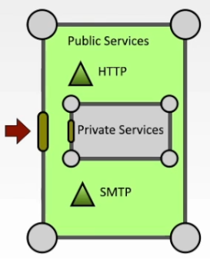

* + Separates private business network from publicly accessible network

## Firewalls & Network Address Translation (NAT)

* Home routers as accidental firewalls
  + Router is responsible for routing packets around a network
    - Home broadband device will often contain router that will route packets between devices in the house (local area network) and the ISP (wide area network)
    - From ISP point of view, router is device that is assigned a ‘real’ IP address
    - Multiple IP addresses can also be allocated for home use
  + Sometimes home user may just use a hub – only one machine attached to it – no routing and IP address is allocated to the attached PC
* DHCP, ISPs and Private Networks
  + An ISP will usually allocate one IP address to a physical line; this will be handled by the local broadband router and modem
    - IP addr may be static or dynamic, where it will periodically change
      * Static allows you to offer a service at definite address
      * Dynamic can make it harder to hack since you are moving target
        + Still possible to offer service by posting the IP addr change but slower
    - Which home computer is assigned this fixed external address?
      * Answer – all and none
      * NAT is used to get around the sharing of one IP addr
        + Has security benefits
* Network Address Translation – NAT
  + One of the tasks of home/private network routers is to perform IP masquerading via Network Address Translation (NAT)
  + This useful feature enables a single ‘real’ IP address to be shared between a group of local machines on a private network connected via a given router
  + Outgoing packet headers are modified to contain the public IP address of the router instead of the local private IP address of the NI device
  + The router maintains a translation table of private network devices and port numbers so that returning external communications are correctly routed to the initiating private NI device
  + Communication initiated by external clients must be pre-configured via port forwarding tables to channel packets to a private NI device

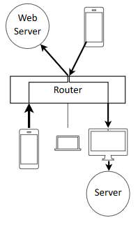

* + From an external point of view, only the router is visible unless port forwarding has been specifically set up to make a service available from a private device
    - A virtual port on the router is mapped to an actual device and port on a private device, identifying a hosted service
    - Externally, the router appears to host the service
  + Private devices are therefore protected from network probes unless specifically exposed
    - Majority of communication originates from within private network
    - Most users do not wish to host services from their home network
      * Those that do usually know what they are doing

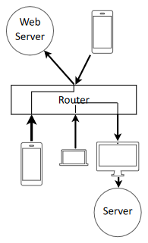

## Useful Defences

* Port knocking
  + Must knock on ports in specific order for router to open them
* VPN
  + What if user requires access to private network services but is outside firewall(s)?
    - VPN connection can be established
    - Creates secure, encrypted connection trough the firewall
    - Comm is then diverted via this connection and ‘appears’ inside the internal network without having to validate against the other firewall checks
  + Enables external trusted client to tunnel through to internal private network
  + Related process to VPNs is TOR
    - Enables user to ‘pop up’ inside another network as though it were their point of origin
* Honey pots
  + When investigating potential security weaknesses or trying to identify attackers, it an be useful to create a ‘Honey Pot’
  + A honey pot is a vulnerable machine that is closely monitored and all access to it is logged
    - Baited to tempt hacker to attack where normal users would not use
      * E.g. use interesting names and accounts
    - Can deliberately infect with a virus to trace communications back to controller
    - Very useful if you wish to determine if you are under attack
    - Exploits network admin’s knowledge of what is good and what is not
    - Water control plant example
* Vulnerability Scanners
  + Checks computers and network architecture for known vulnerabilities
  + Cannot always fully test weaknesses since likely to break live system
    - Best to test on system before it is deployed
  + Metasploit is a well-known vulnerability scanner
    - Available for common OS’s
    - Used by both researchers and hackers to check systems